**Snowflake**

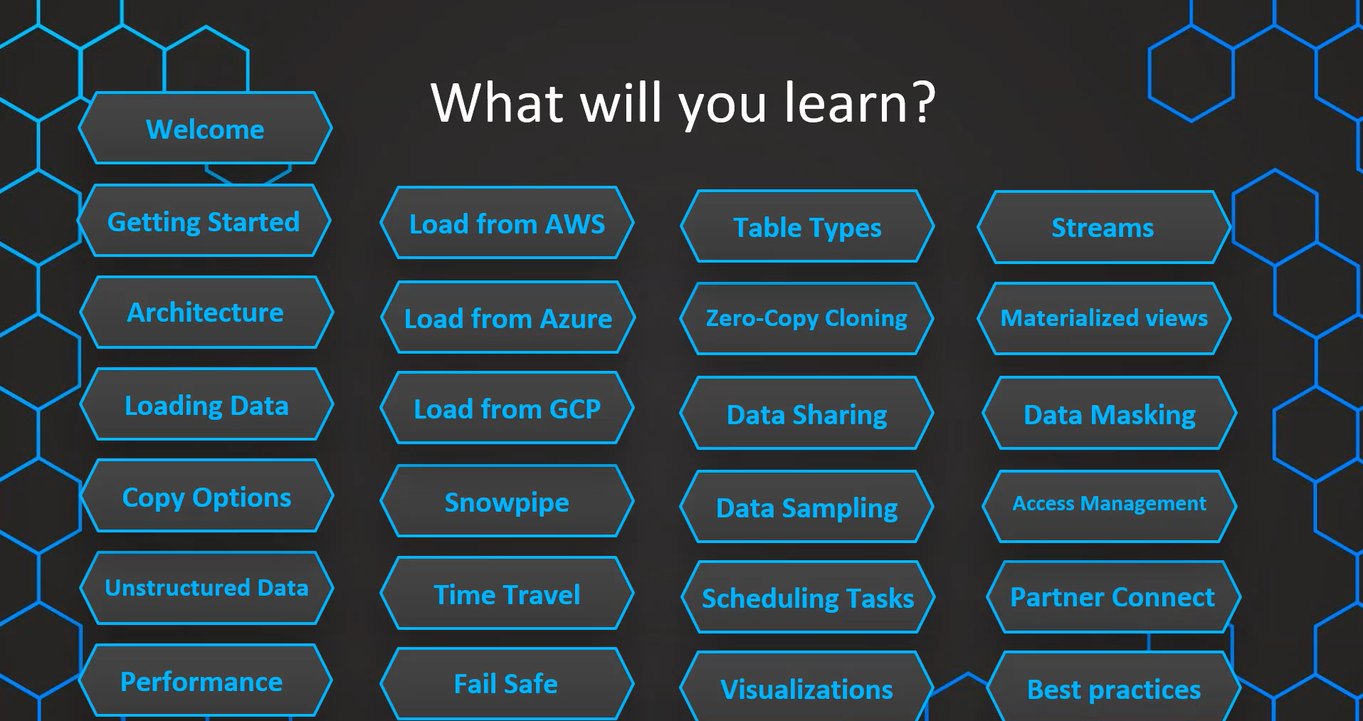

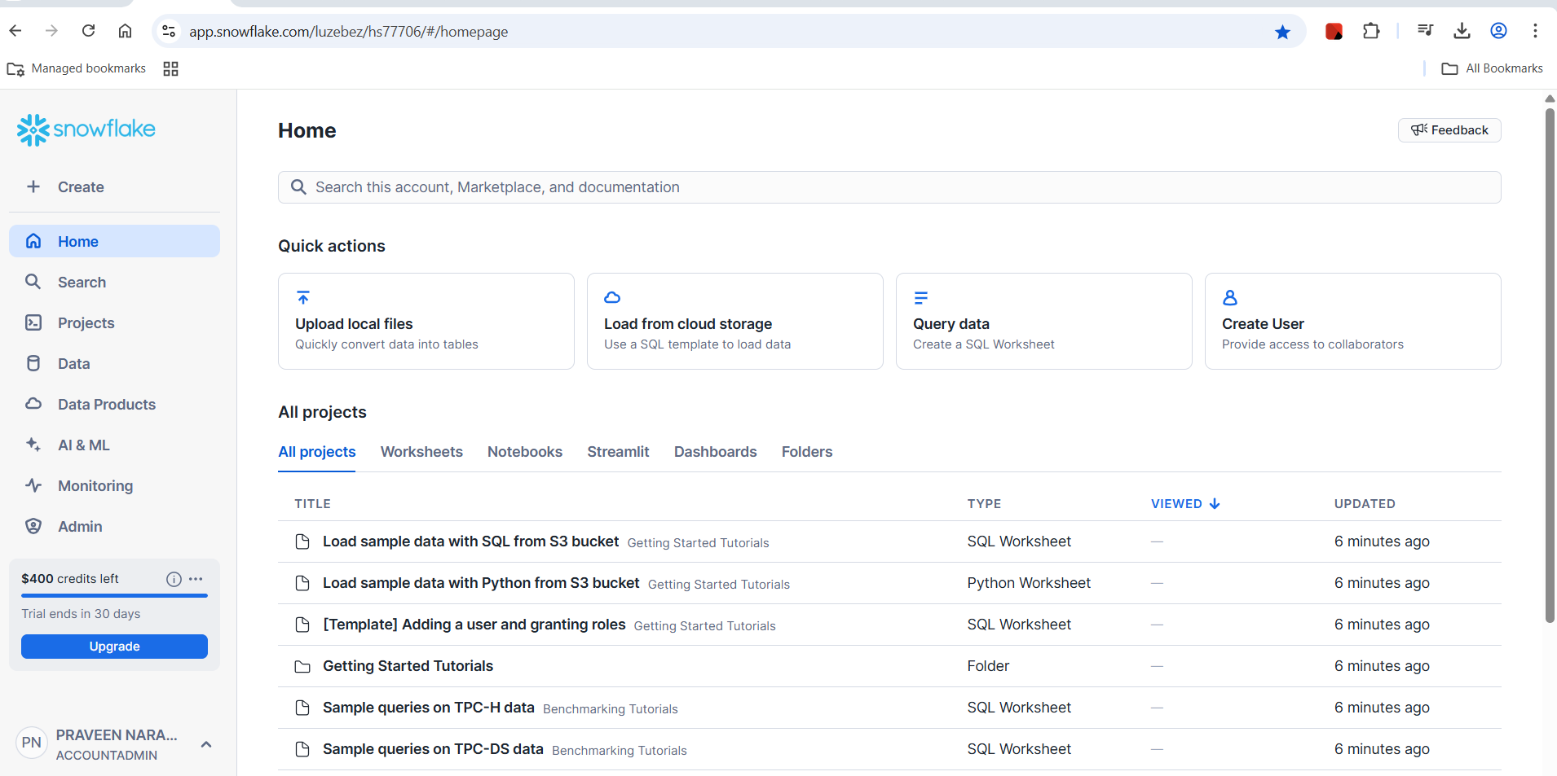

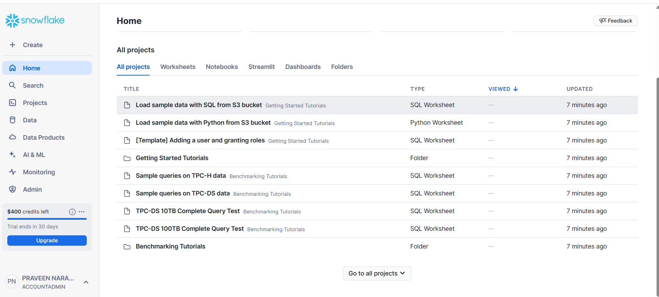

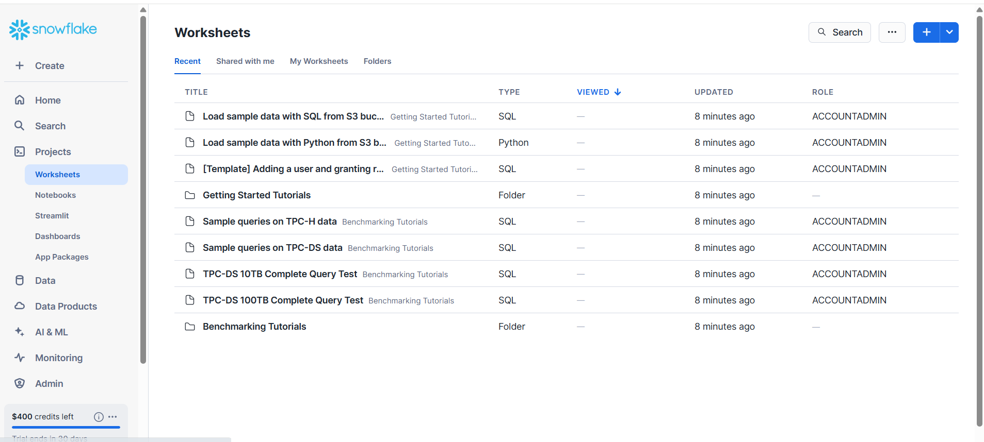

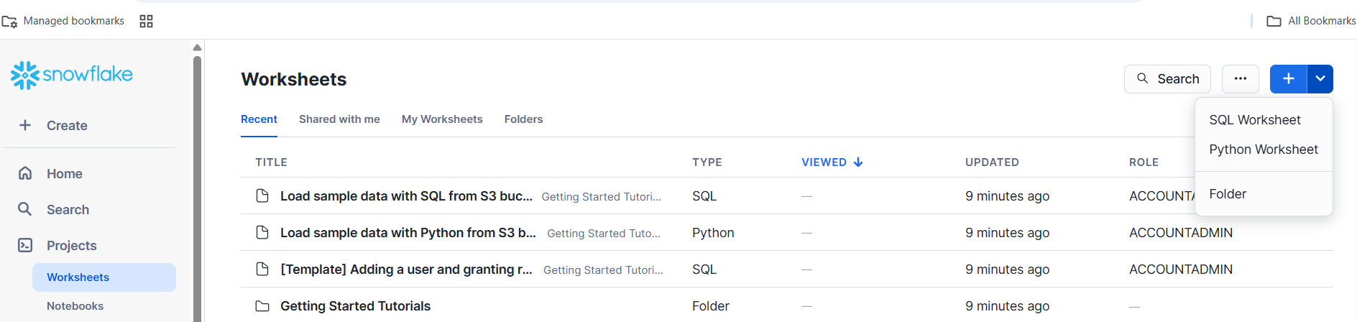

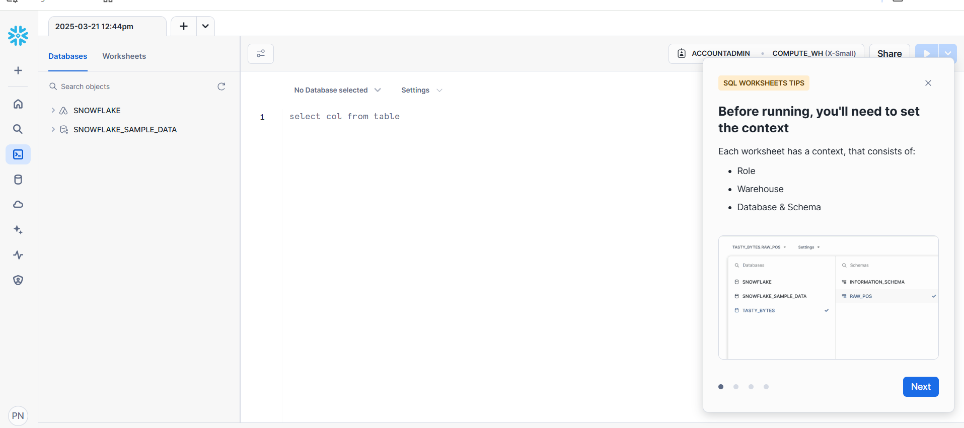

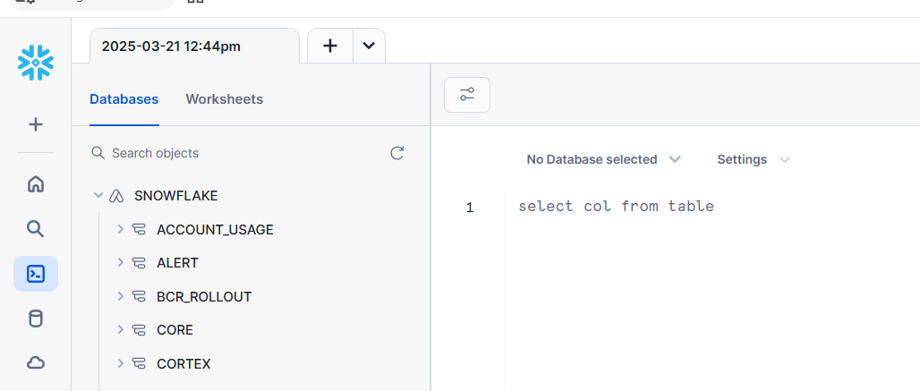

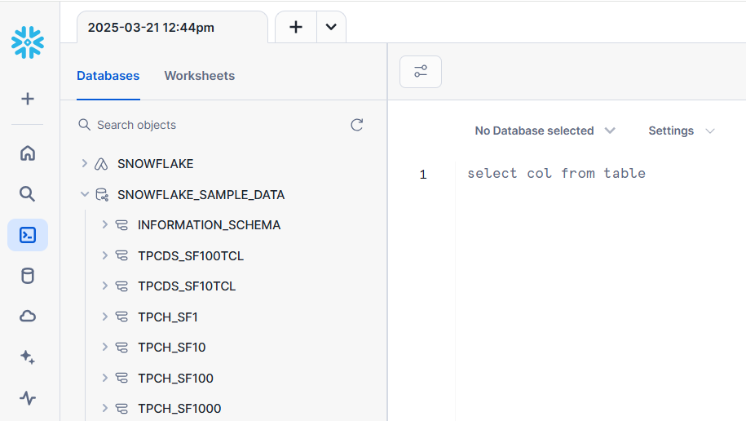

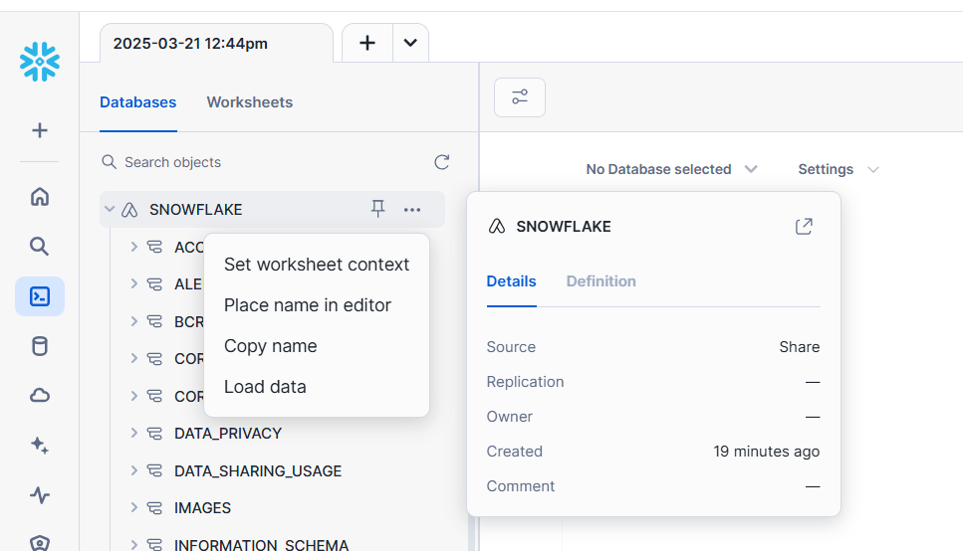

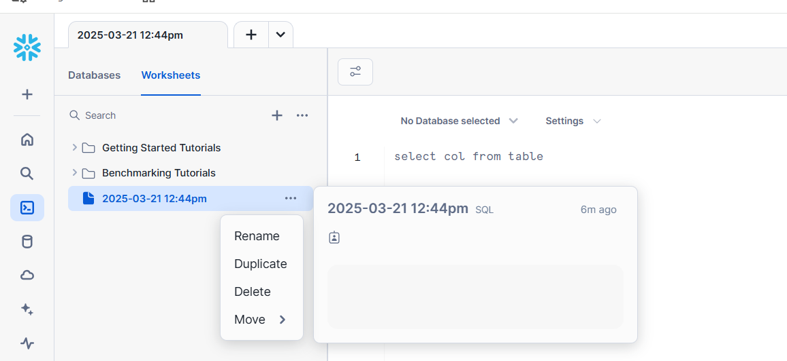

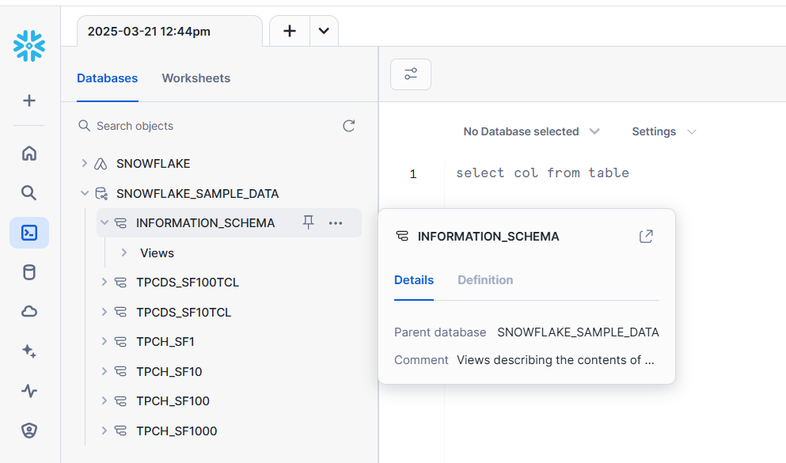

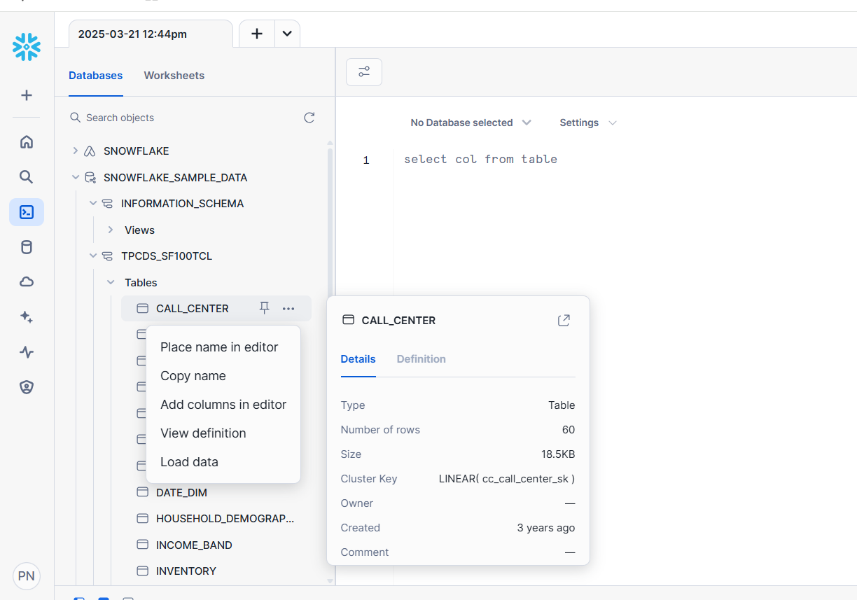

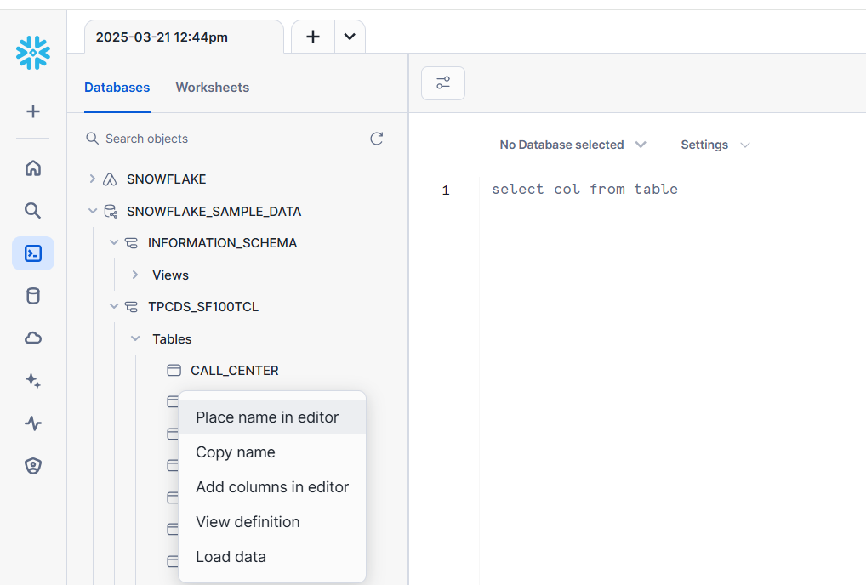

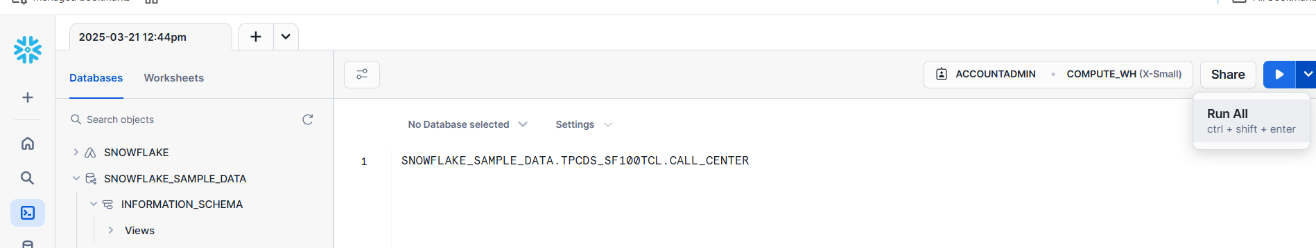

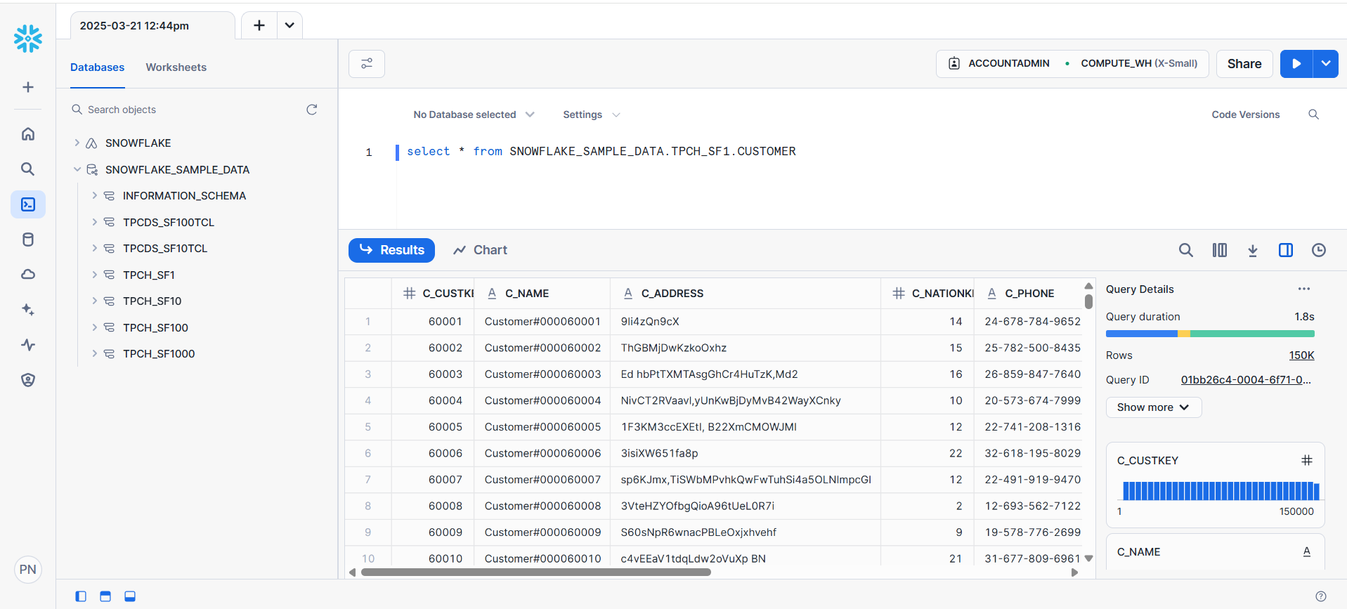

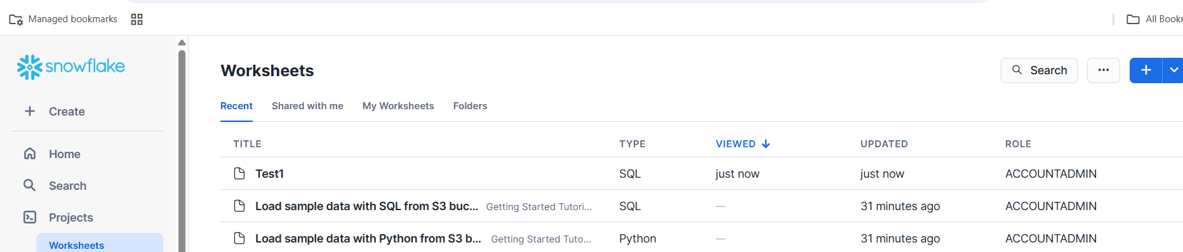

**Here we are selecting the database.schema_name**

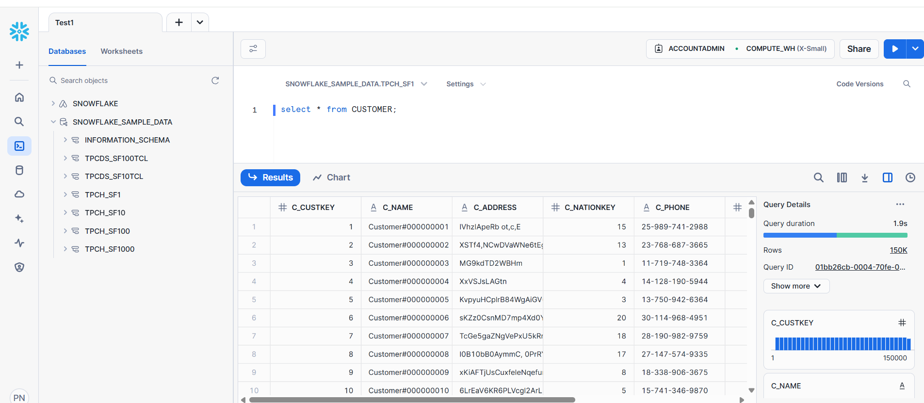

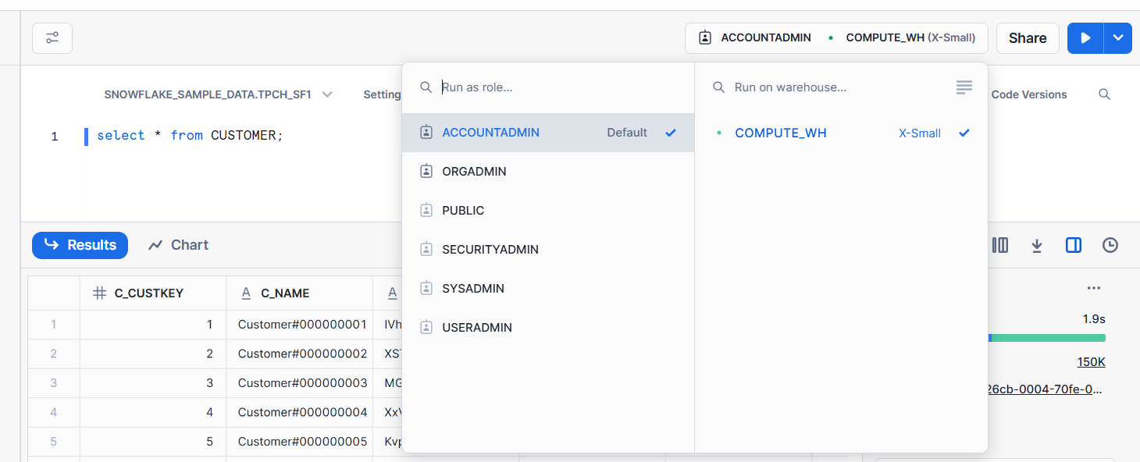

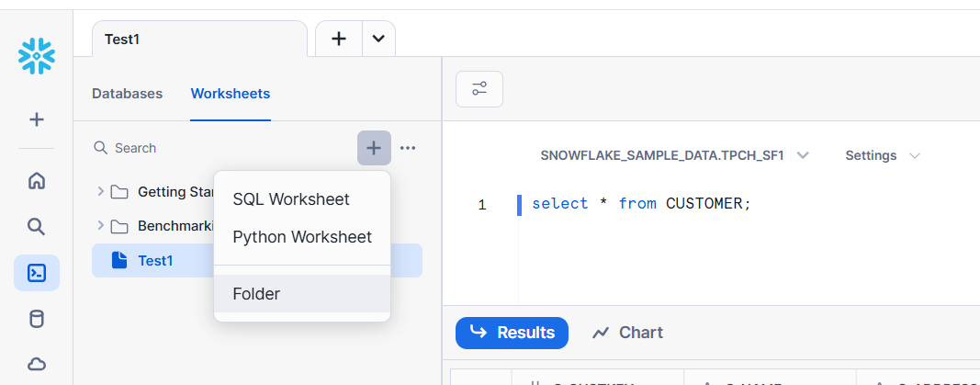

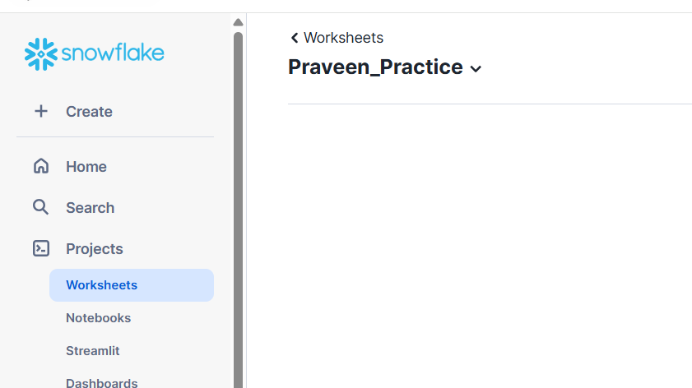

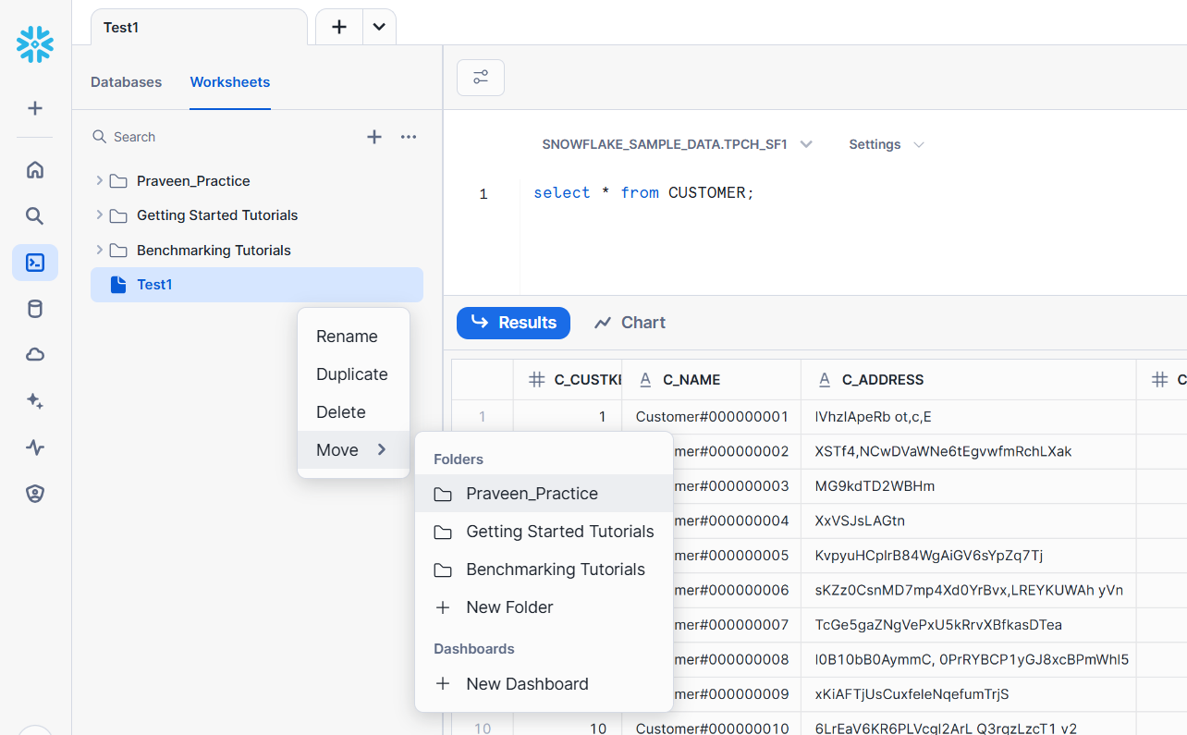

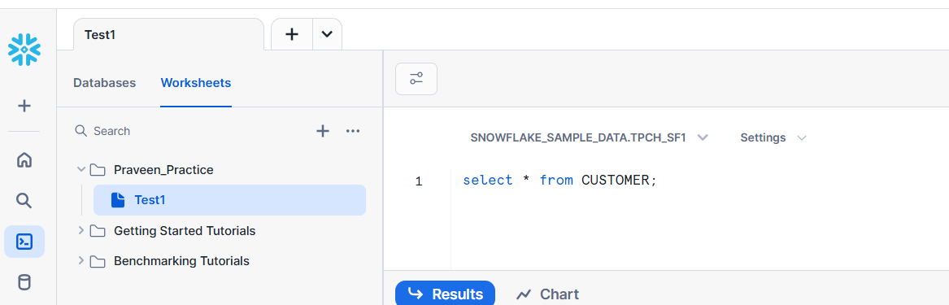

**Snowflake Architecture**

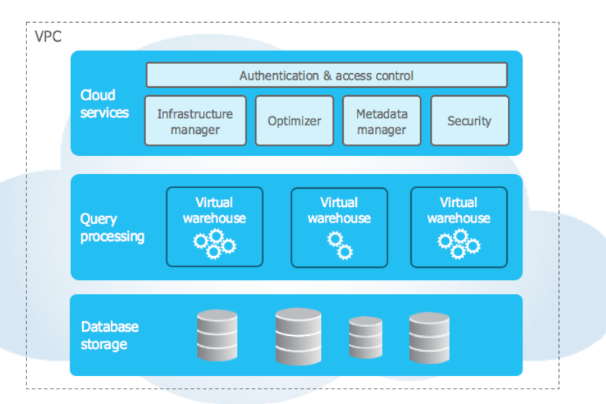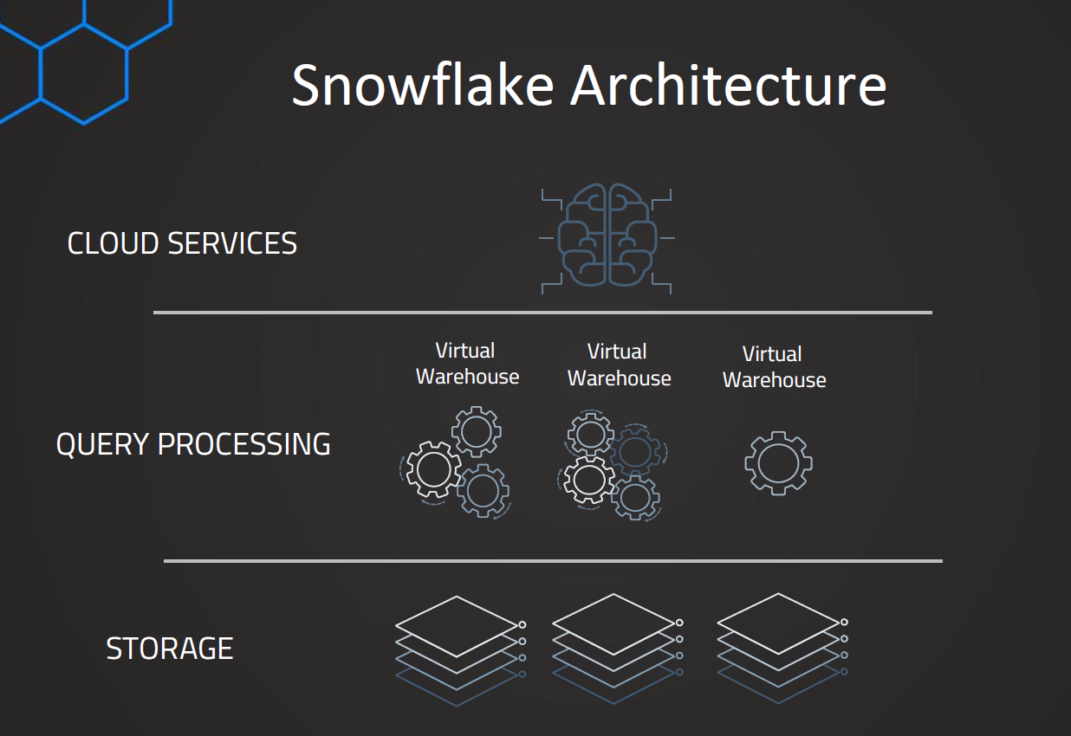

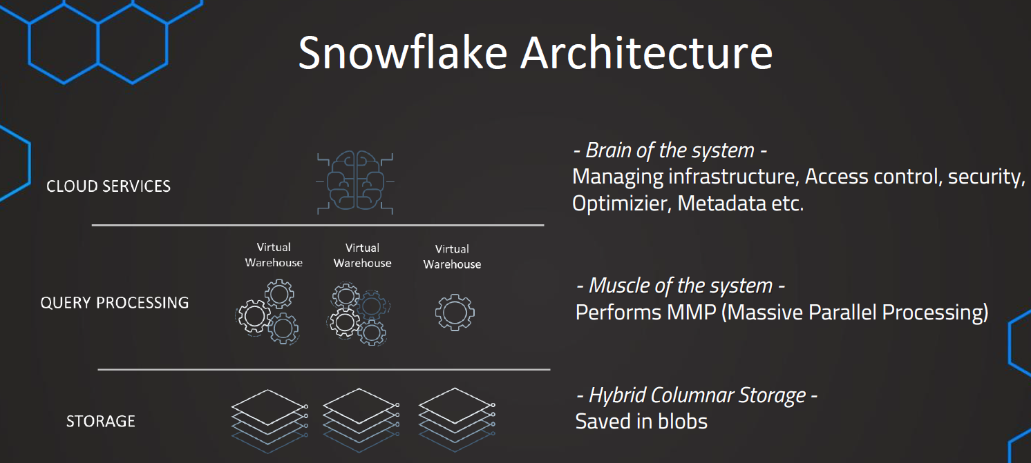

1. **Storage layer**

**Hybrid Columnar Storage (saved in blobs)**

1. **Query Processing layer**

* **Muscle of the system**

**Performs MMP (massive parallel processing)**

1. **Cloud Services**

**It’s a brain of the system**

**Managing infrastructure, Access control security, optimizer, metadata etc**

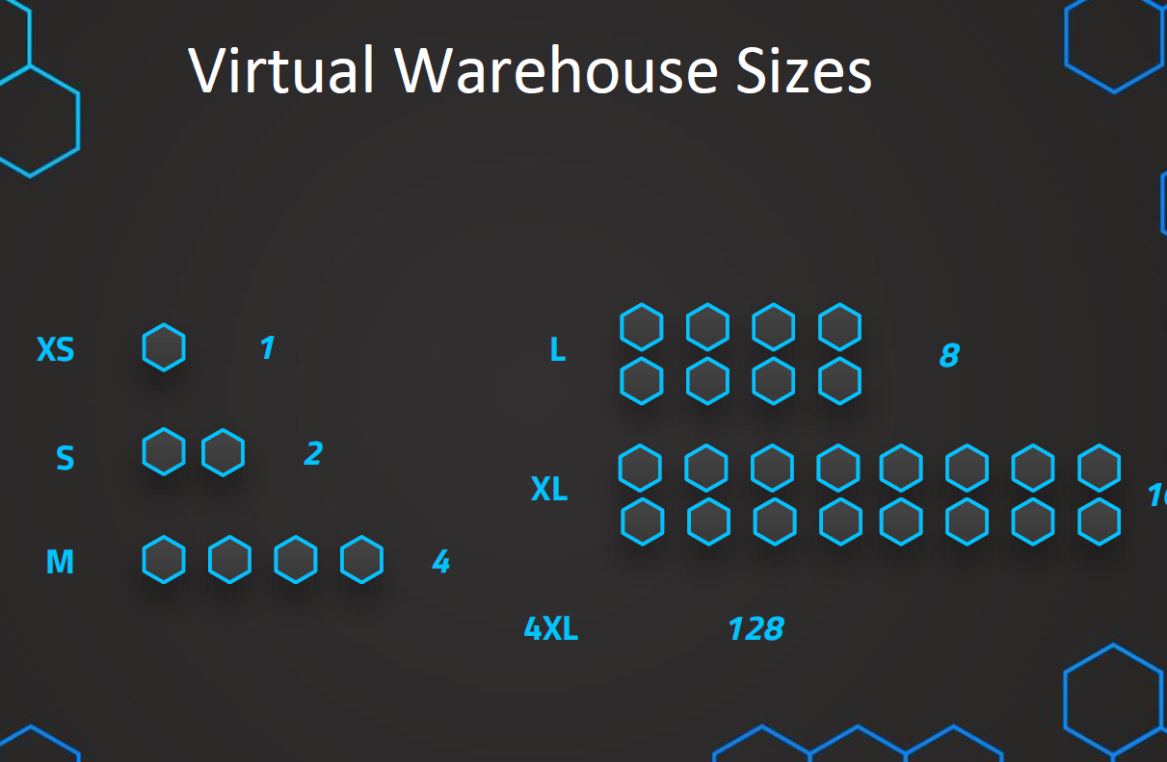

Here each one is a server.

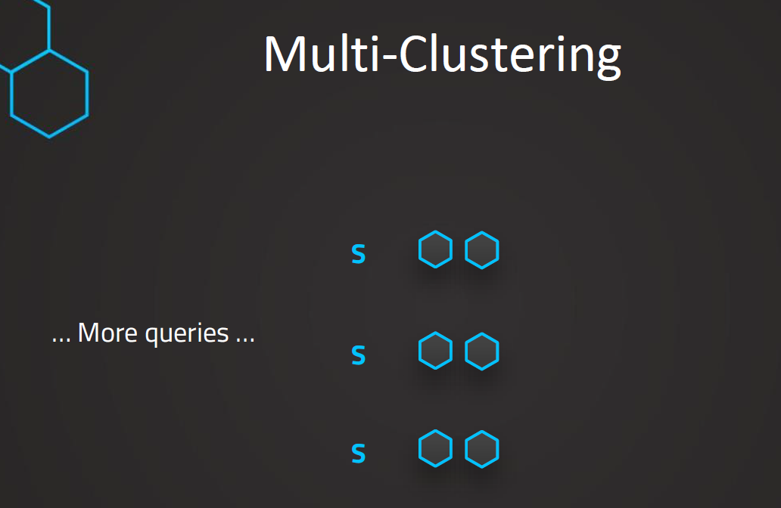

Snowflake supports multi-clustering.

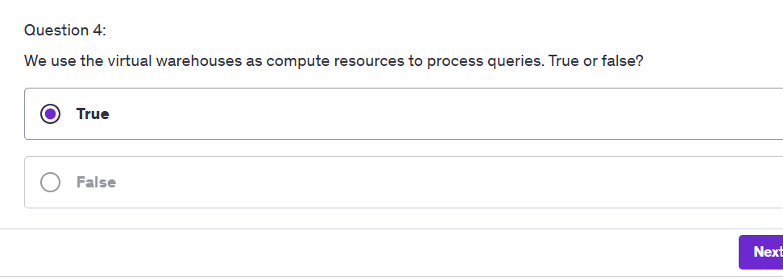

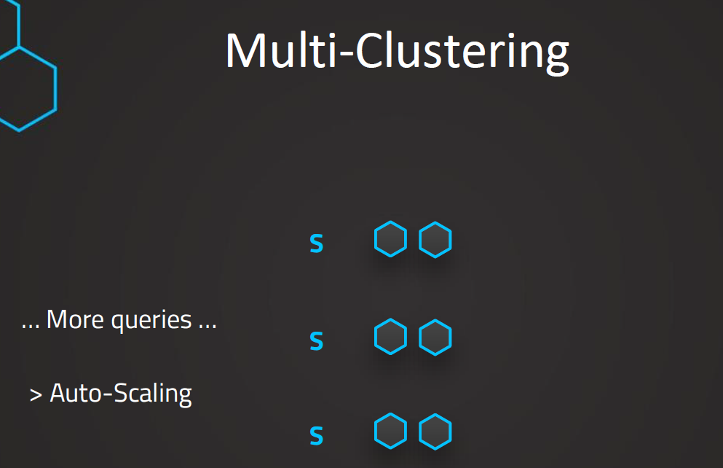

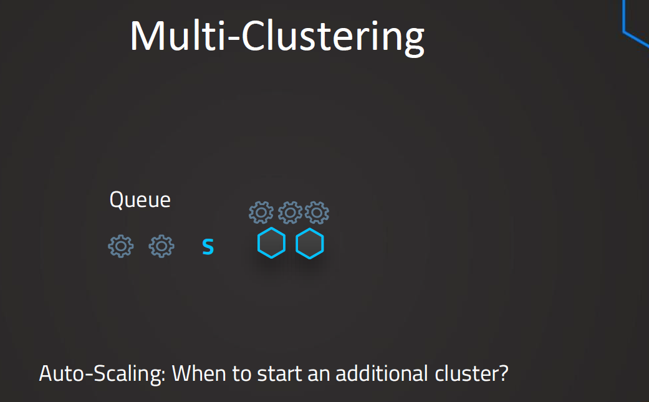

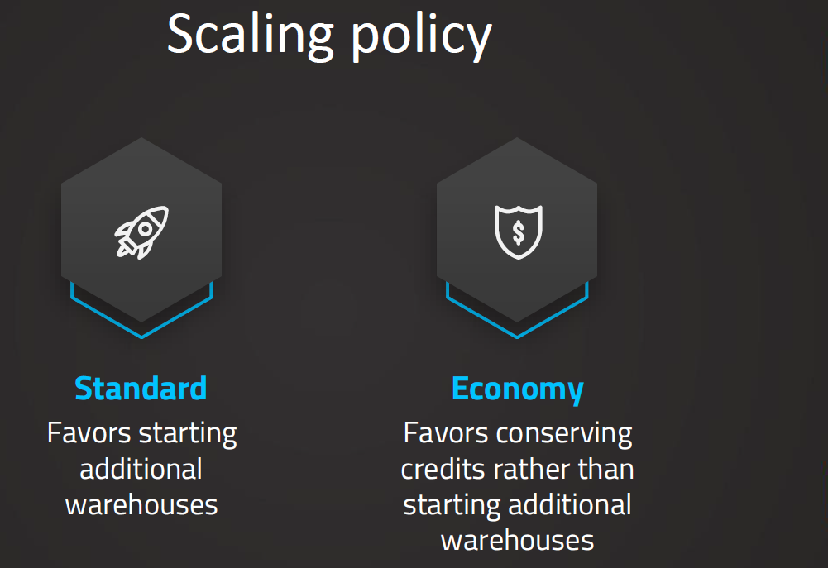

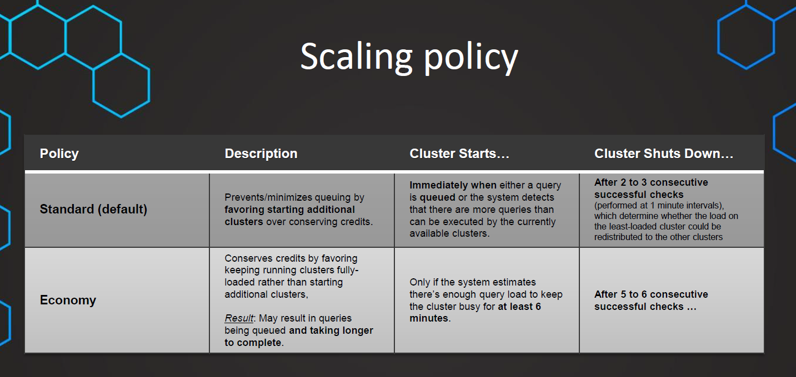

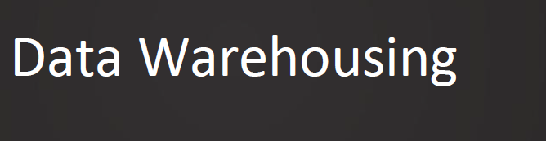

There are 2 ways to setup the warehouse

1.interface

2.SQL commands

We need role of **account admin** or **security admin** to see the existing warehouse that I available by default.

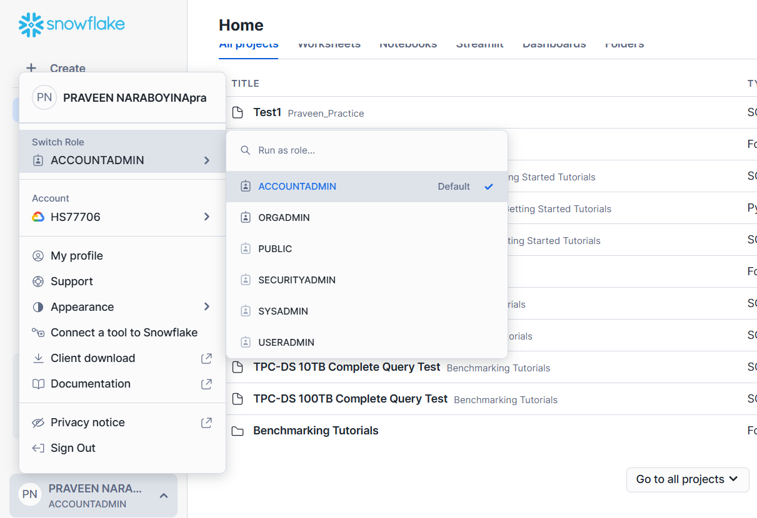

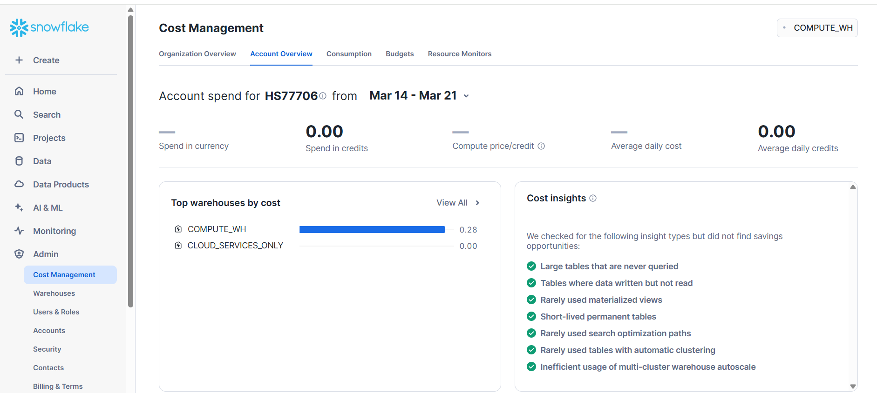

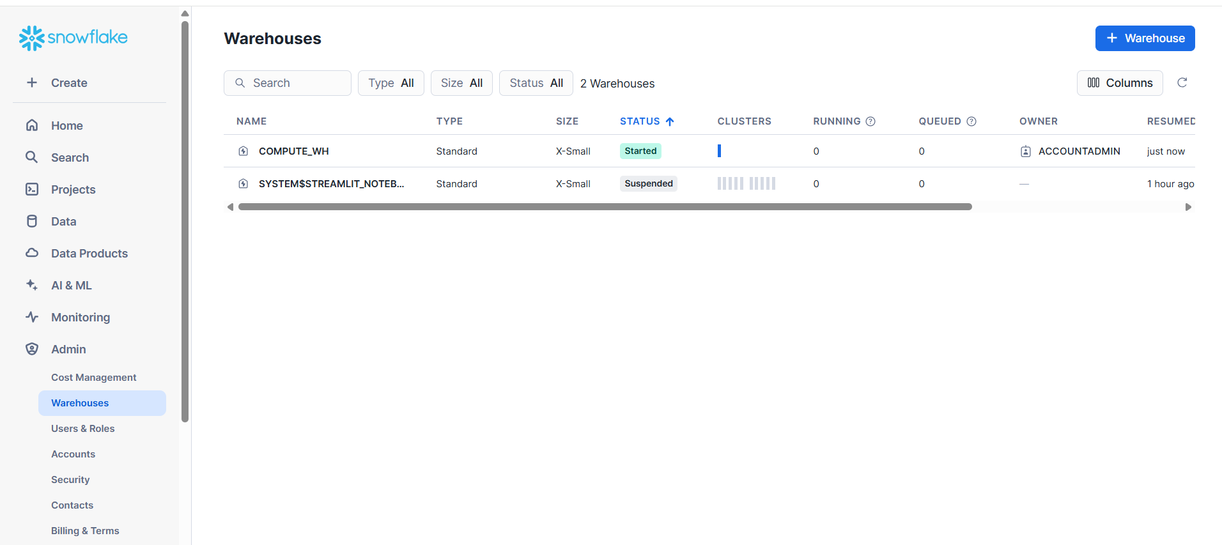

SYSADMIN can create the warehouses.

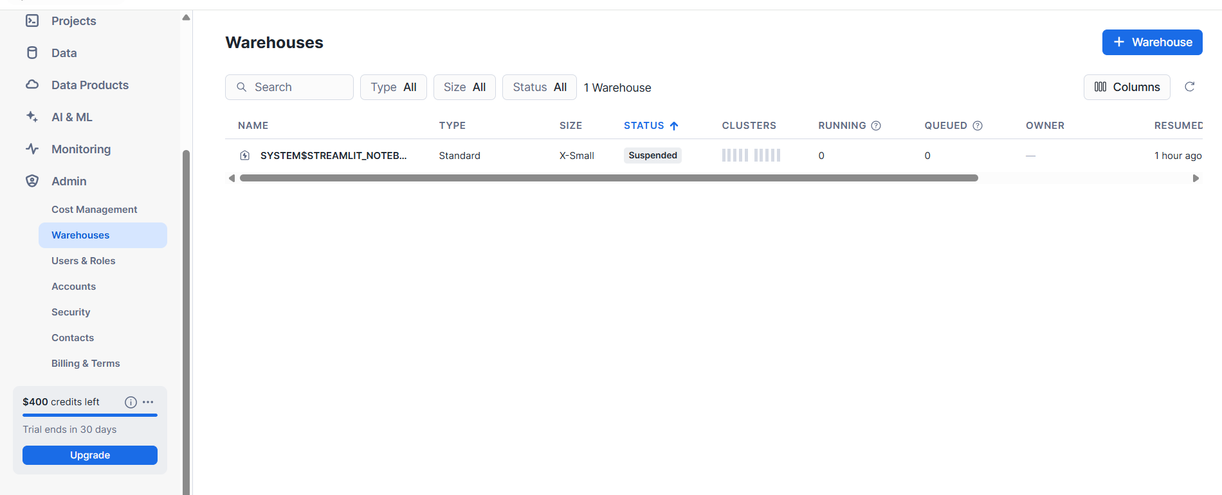

Security Admin is the 2nd most powerful user.

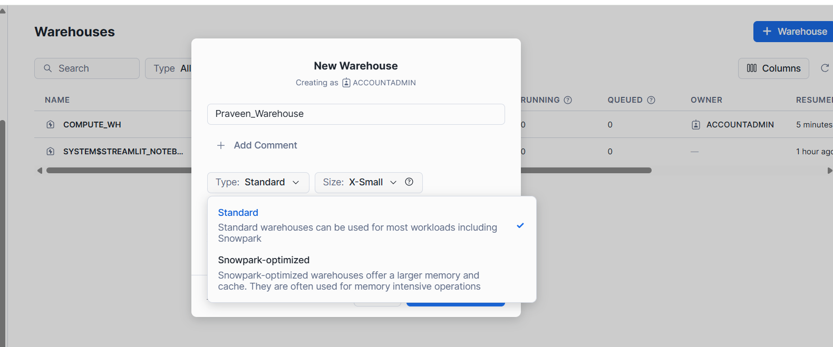

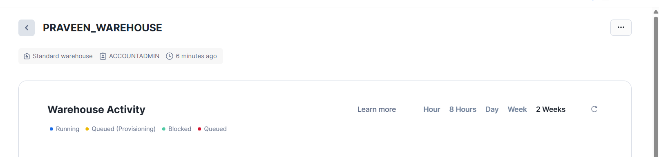

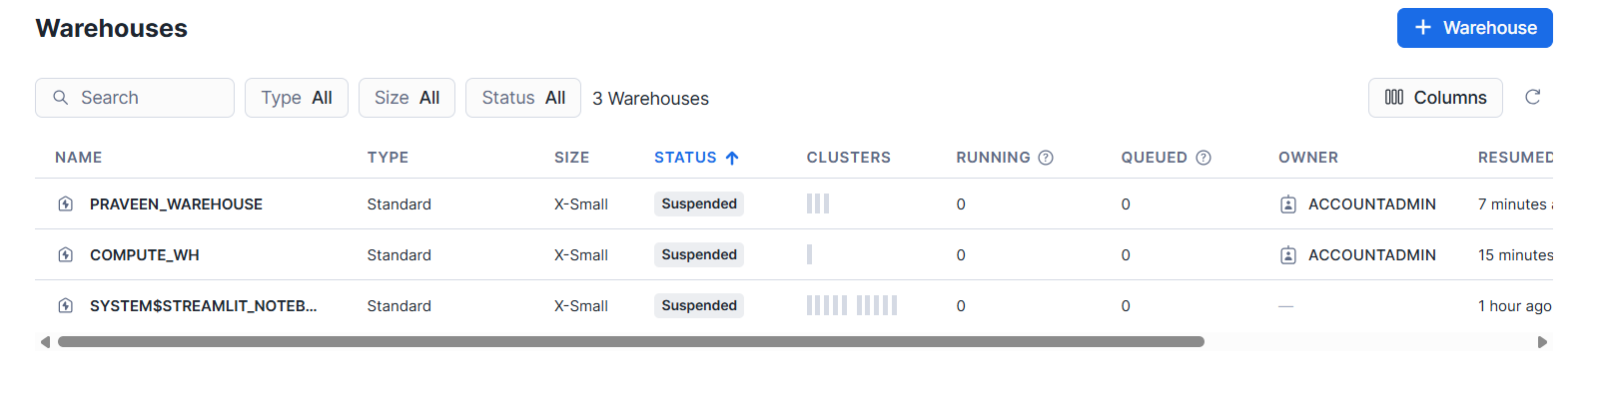

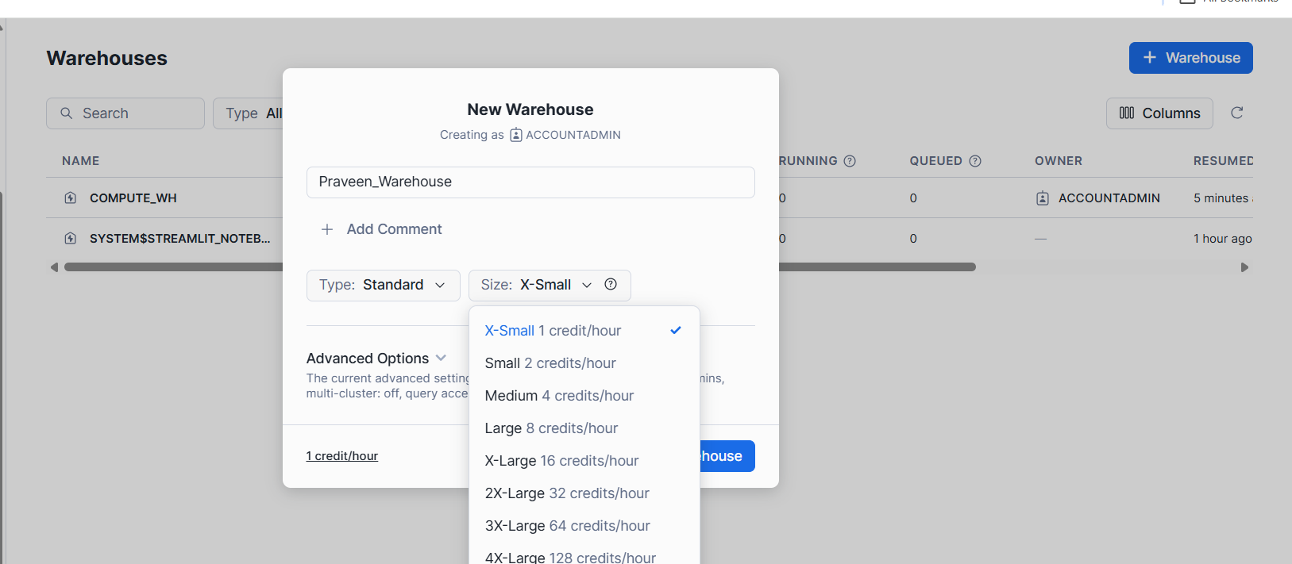

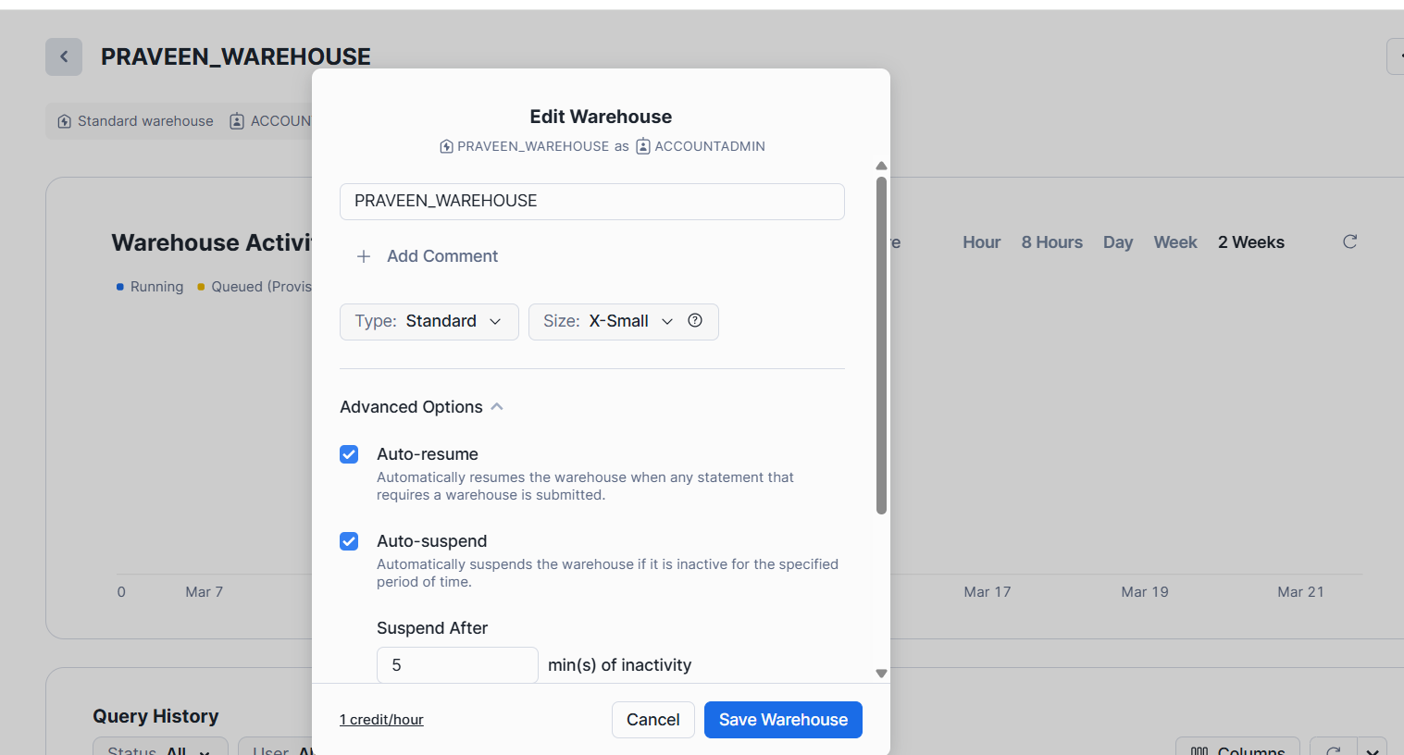

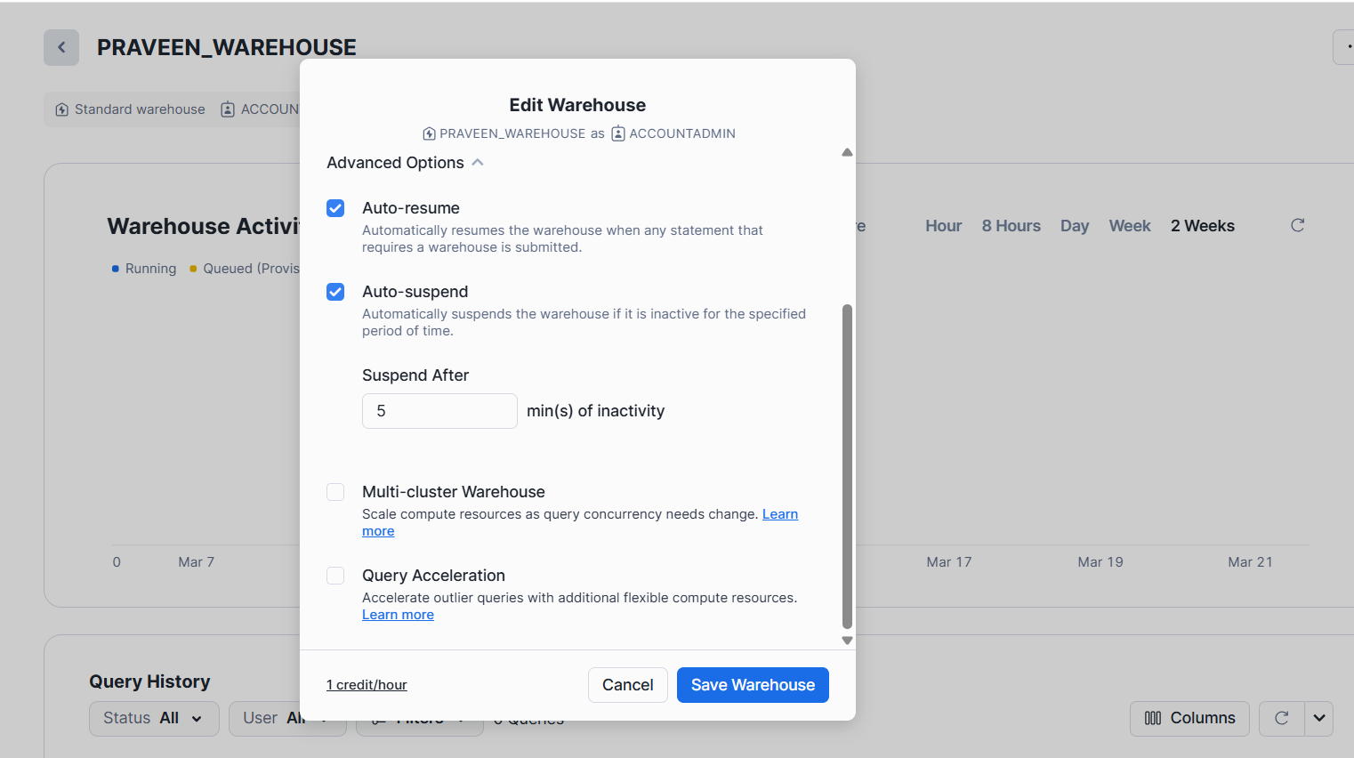

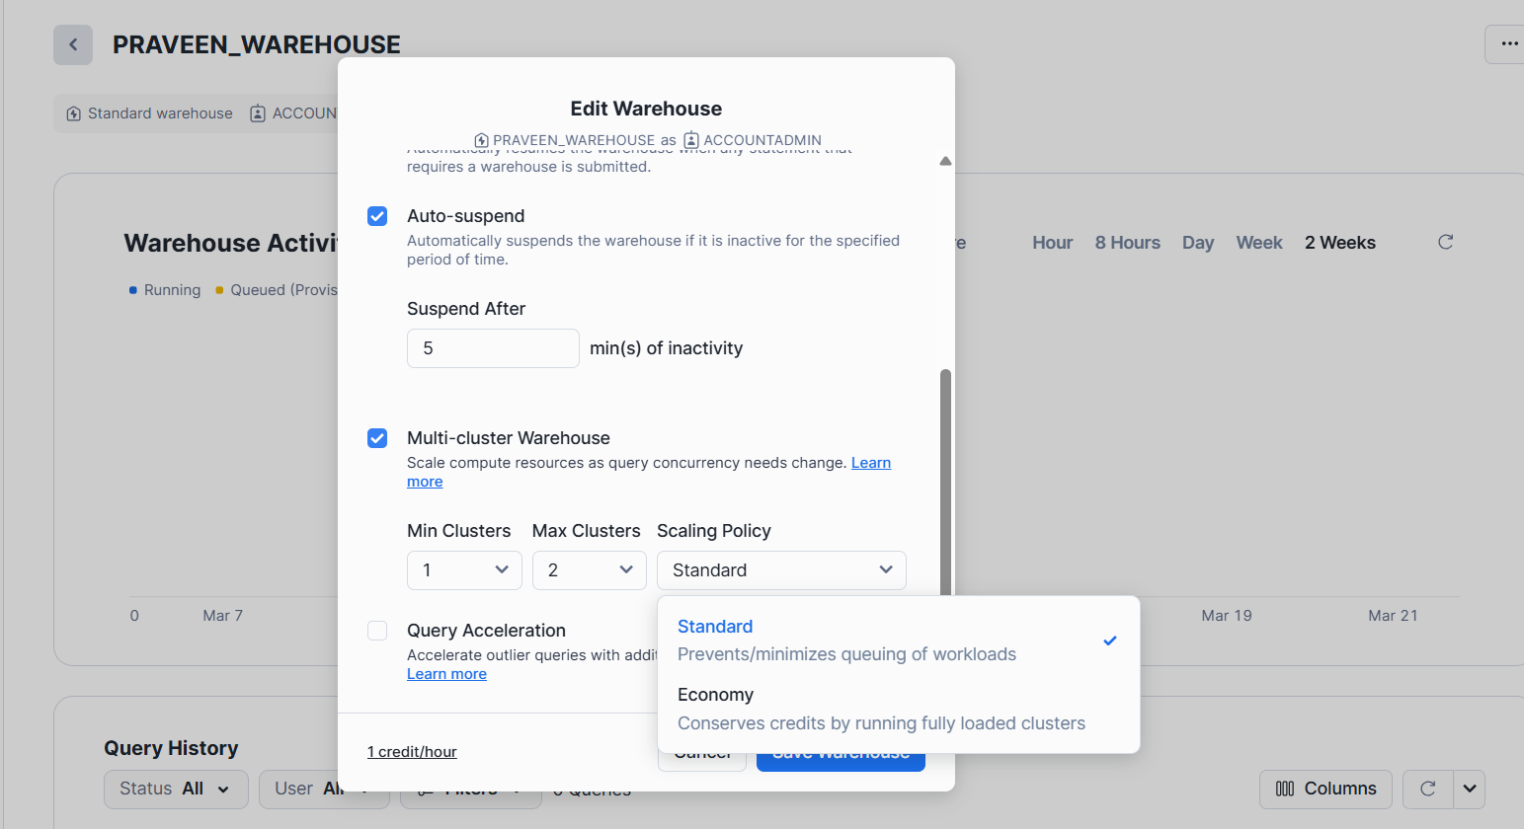

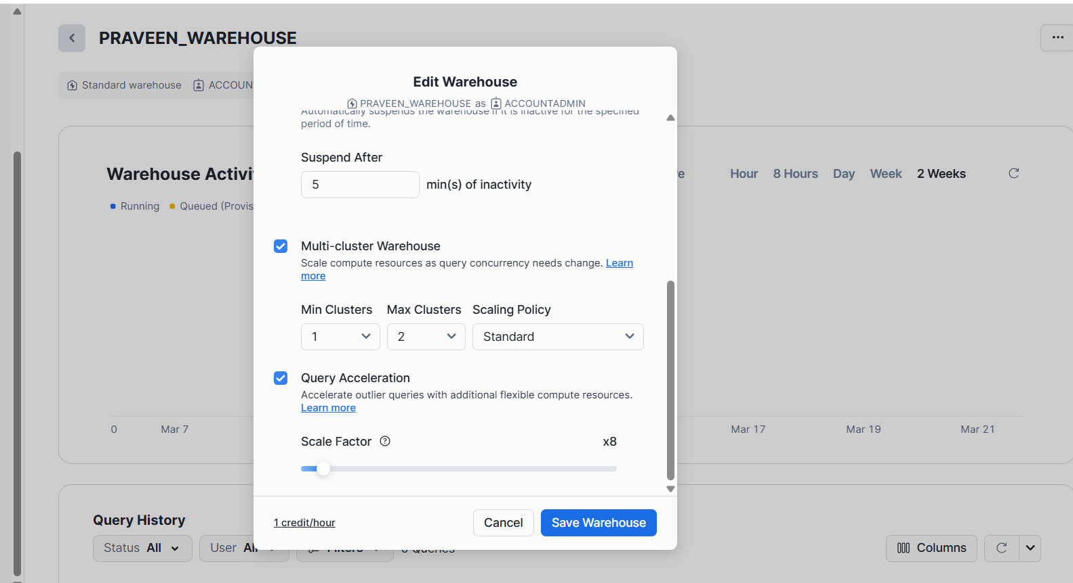

**Setting up warehouse using SQL**

**Creation of Warehouse**

CREATE OR REPLACE WAREHOUSE SAADVIK

WITH

WAREHOUSE_SIZE = XSMALL

MIN_CLUSTER_COUNT = 1

MAX_CLUSTER_COUNT = 3

COMMENT = "This is new warehouse"

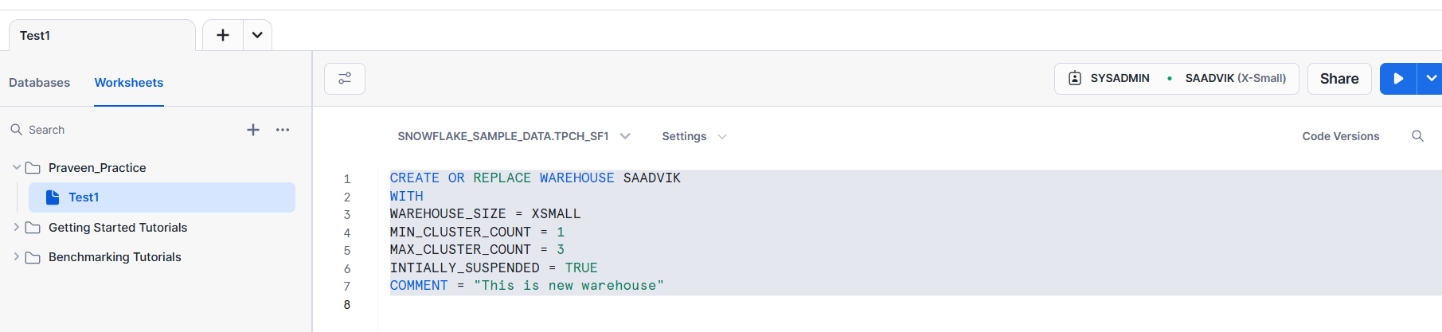

After creating WAREHOUSE, its automatically starts with WAEHOUSE we created.

CREATE OR REPLACE WAREHOUSE SAADVIK

WITH

WAREHOUSE_SIZE = XSMALL

AUTO_SUSPEND = 300

SCALING_POLICY = ‘ECONOMY’

MIN_CLUSTER_COUNT = 1

MAX_CLUSTER_COUNT = 3

INTIALLY_SUSPENDED = TRUE

COMMENT "This is new warehouse"

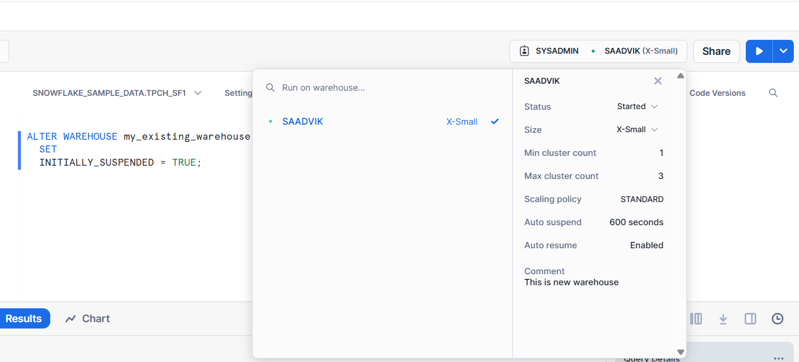

**Alter the warehouse**

ALTER WAREHOUSE SAADVIK **RESUME (Properties)**

ALTER WAREHOUSE SAADVIK SET **WAREHOUSE_SIZE = XSMALL**

DROP WAREHOUSE SAADVIK

**Scaling Policies**

**Multi Clustering Scenarios**

When we have more workloads means when we have more queries or more users

In peak hours in that scenario, we will use.

**Auto Scaling Policy**

When to start additional clusters

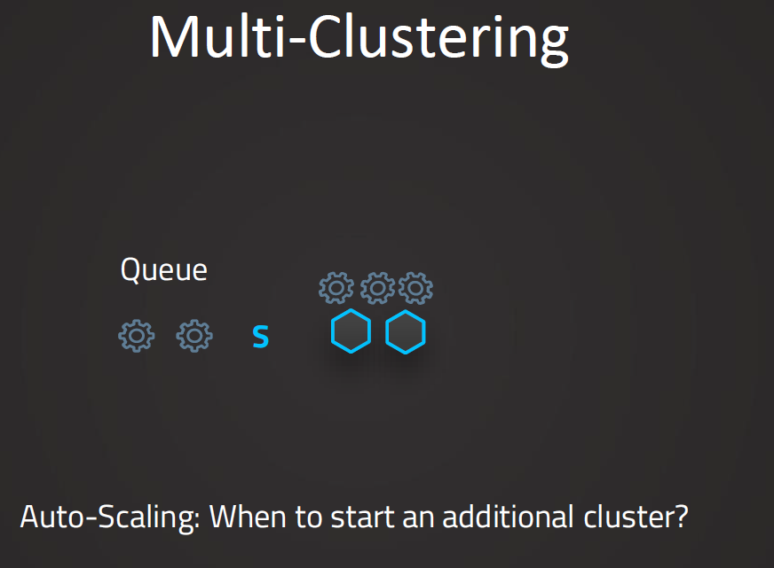

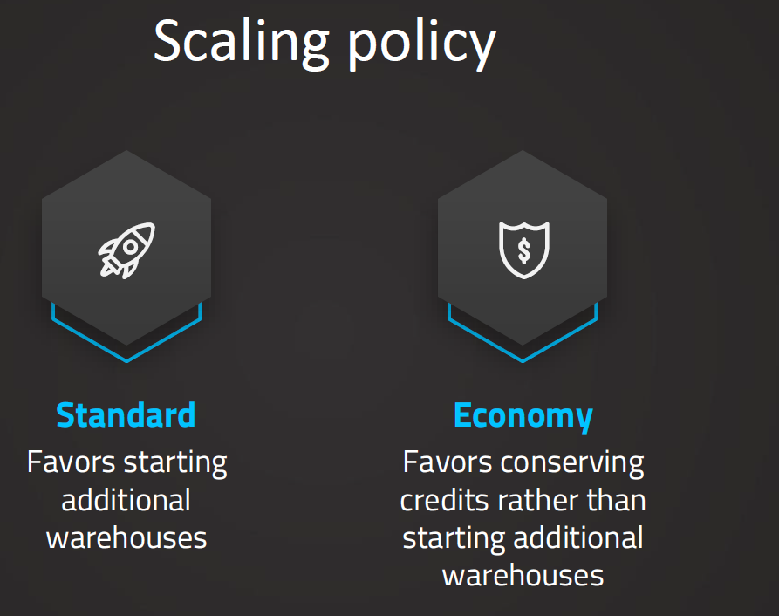

**Standard** Scaling policy is default Scaling policy.

Its favor starting additional warehouses.

In Standard Policy Clusters started immediately when a query would be “**QUEUED**” or even if system detects more queries that can be processed currently by the available clusters.

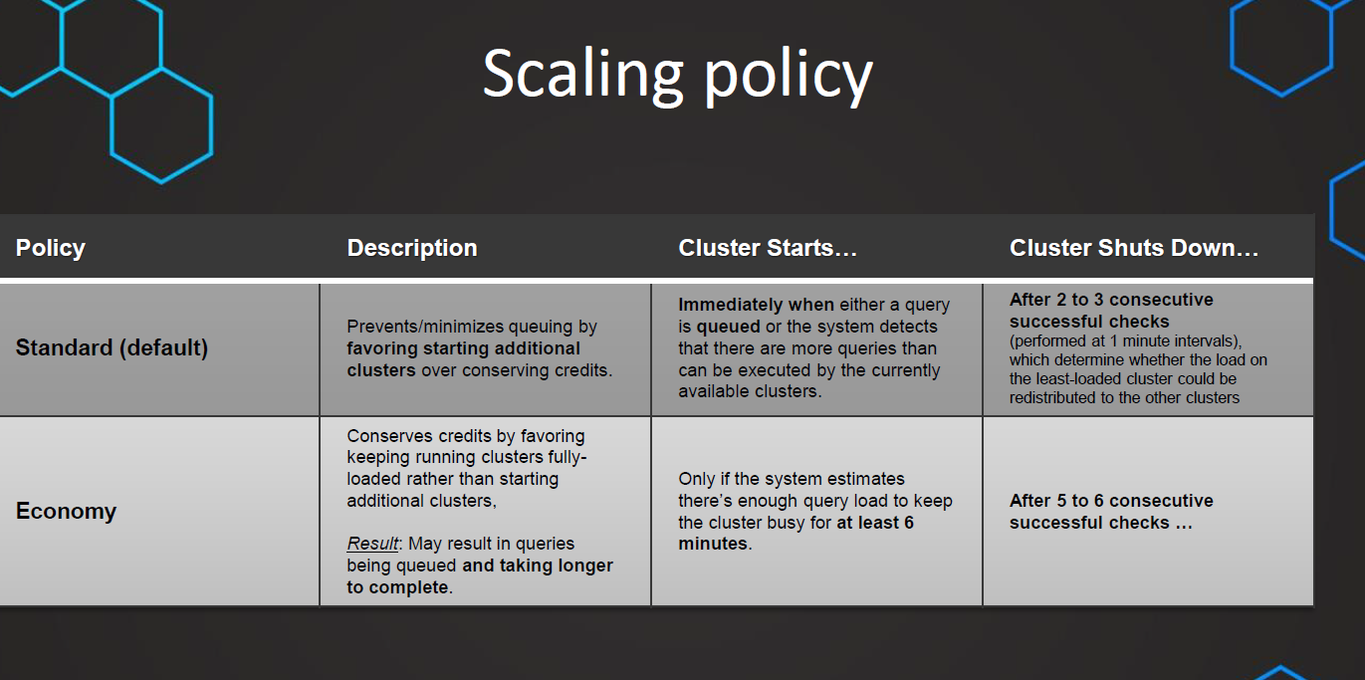

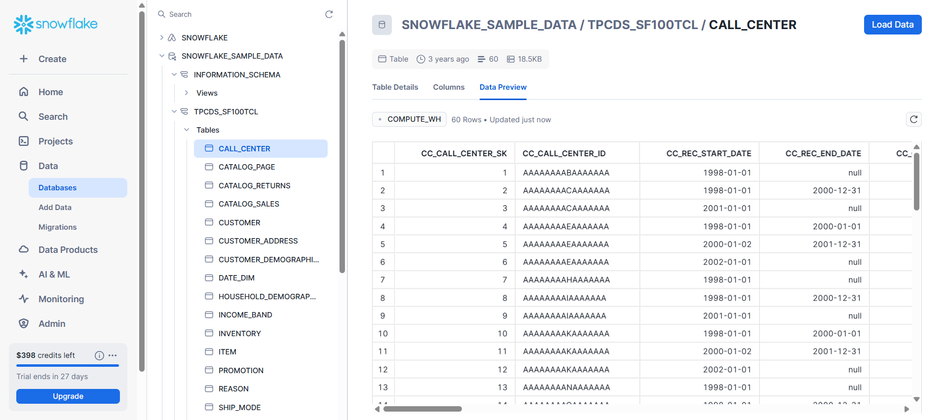

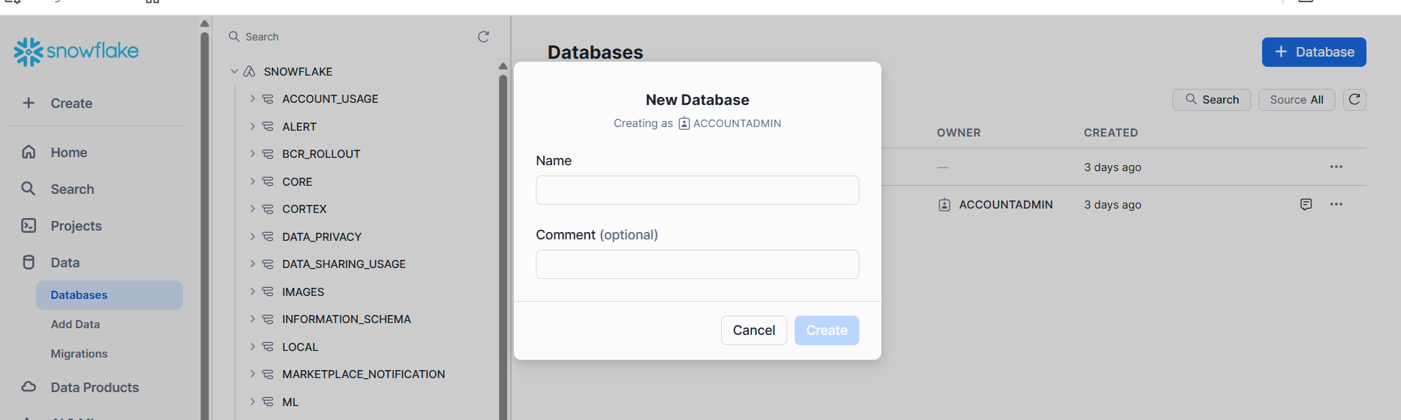

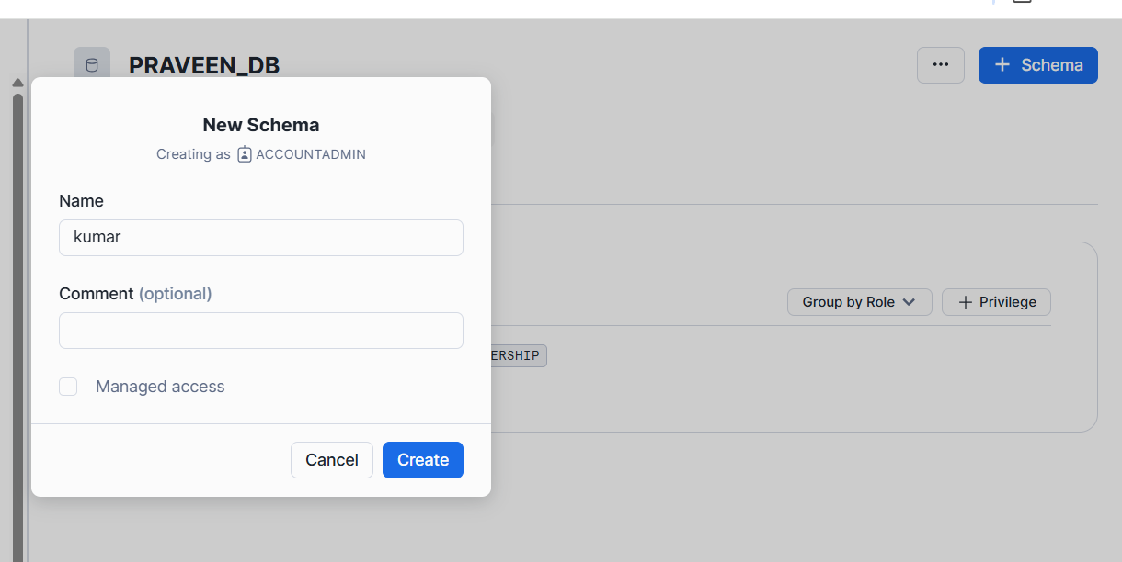

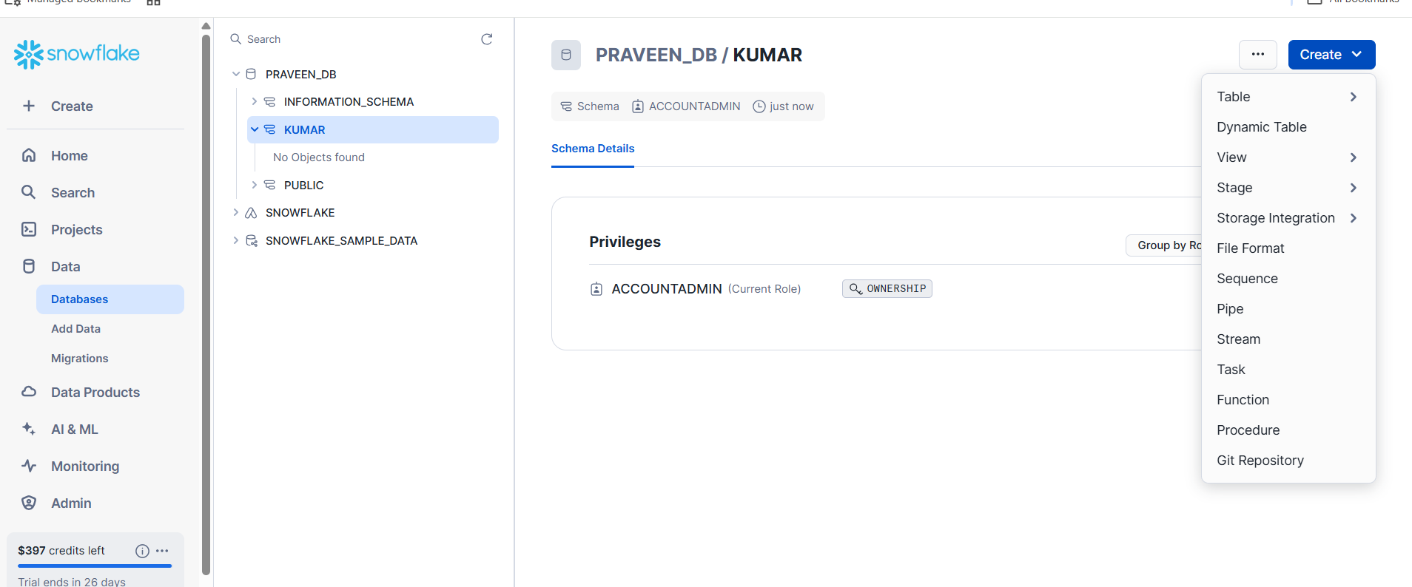

Create --🡪 Table

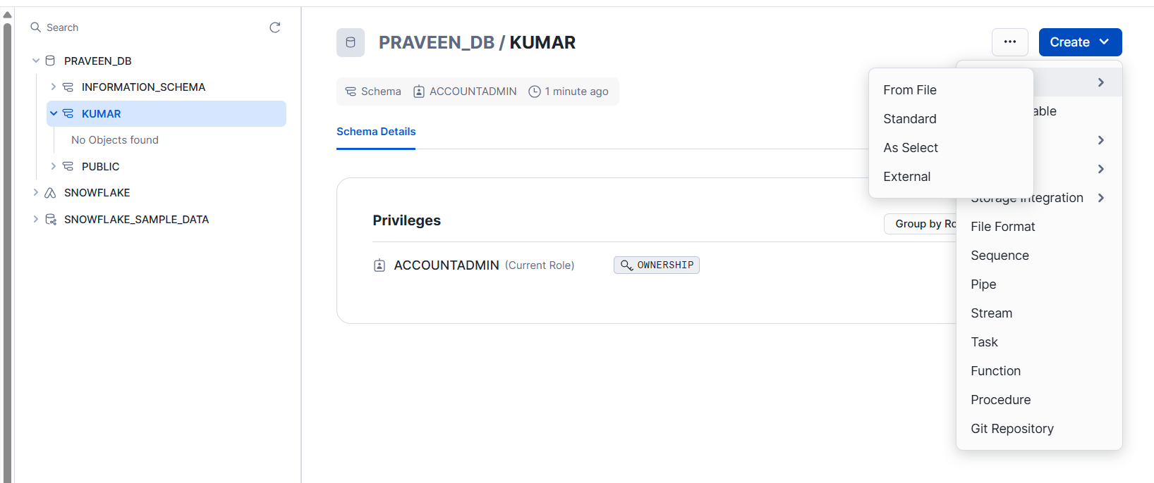

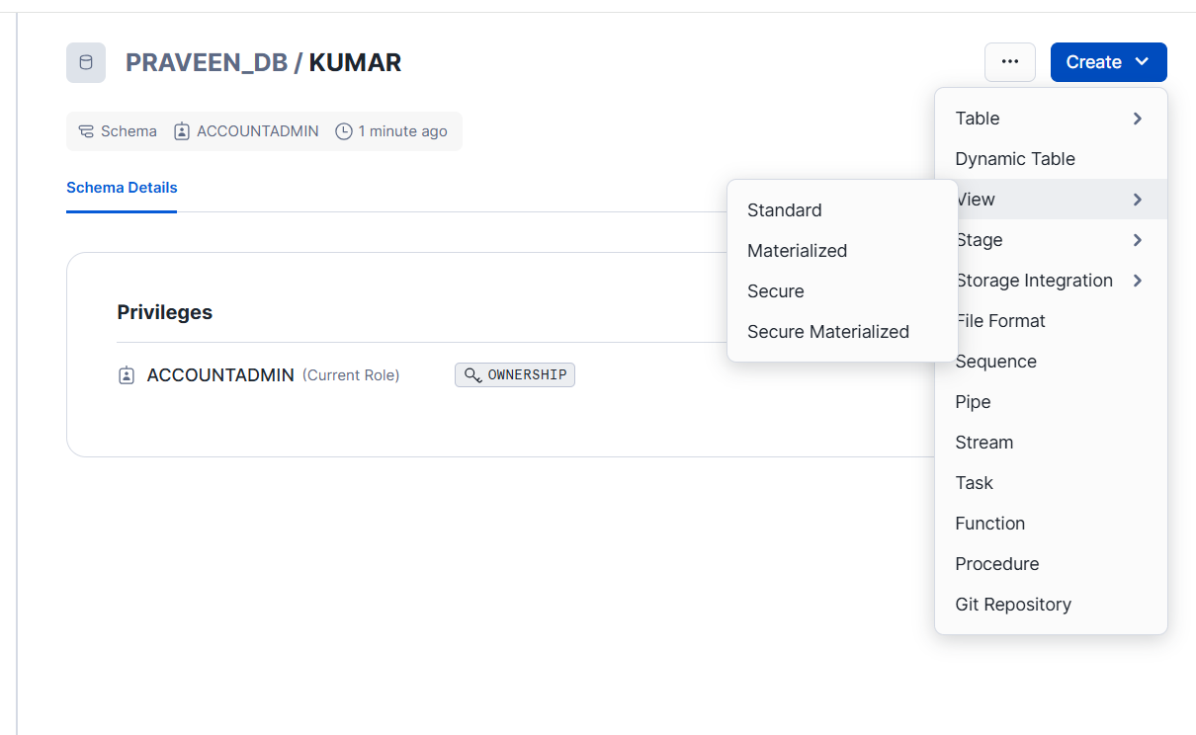

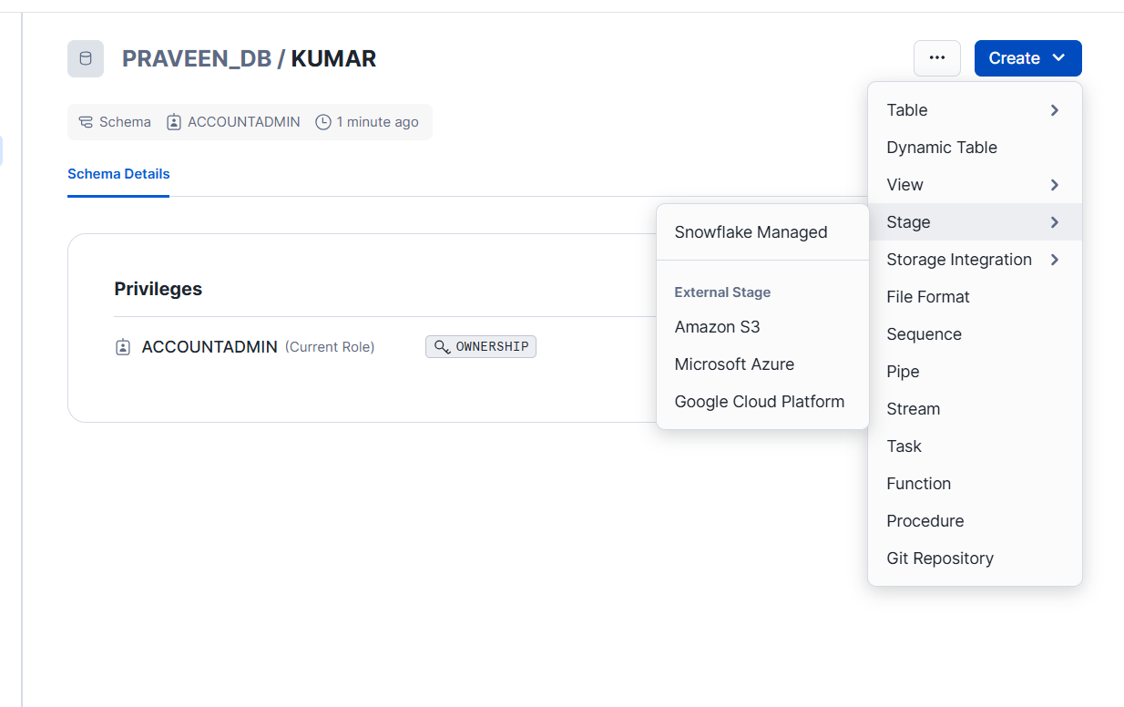

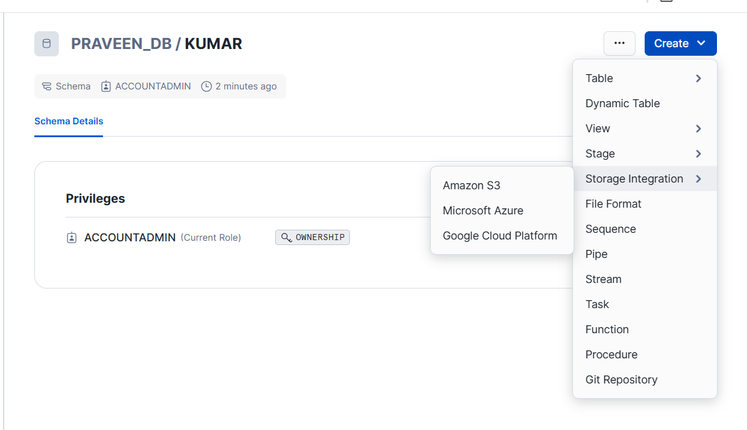

Table ---- From File

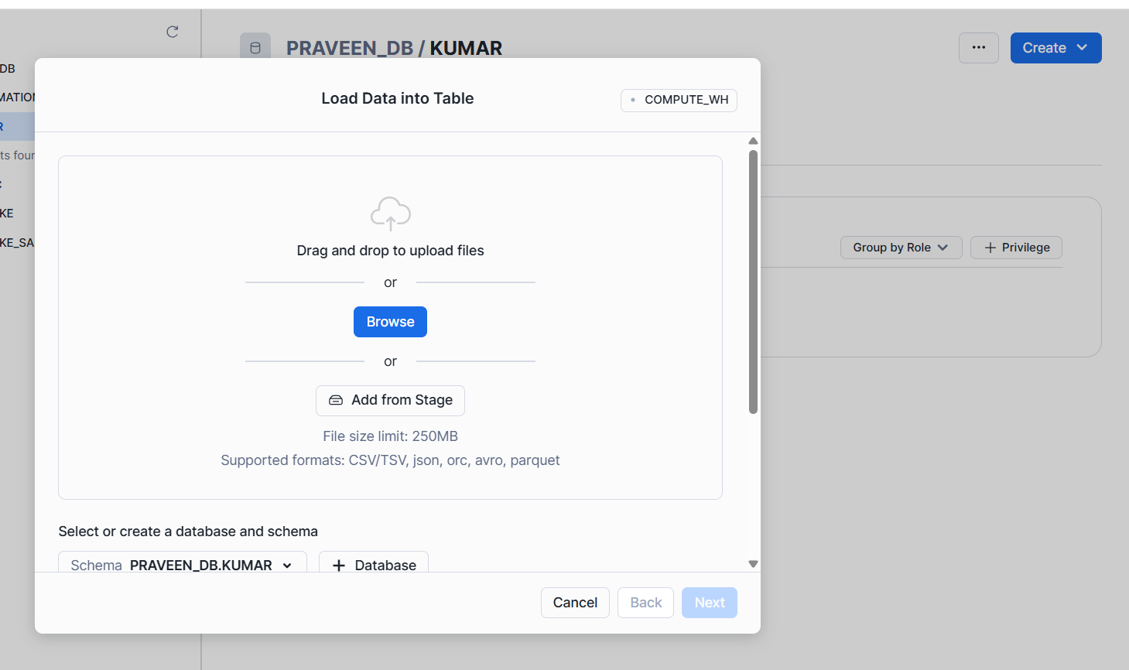

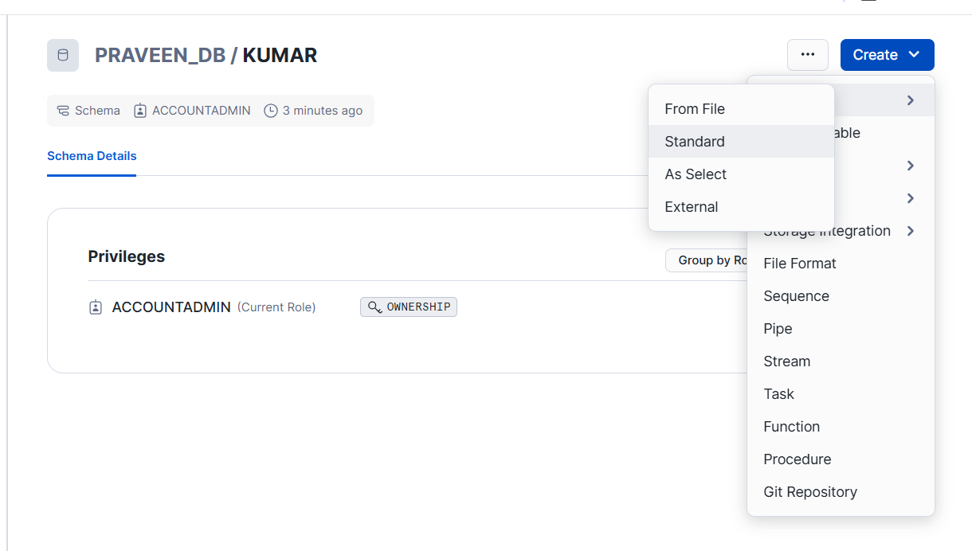

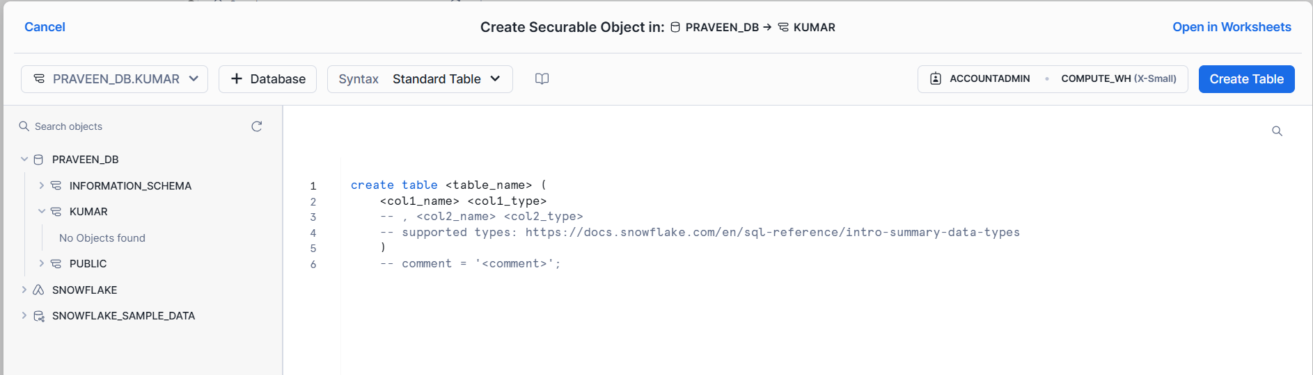

**Load Data into tables**

//Rename data base & creating the table + meta data

ALTER DATABASE FIRST_DB RENAME TO OUR_FIRST_DB;

CREATE TABLE "OUR_FIRST_DB"."PUBLIC"."LOAN_PAYMENT" (

"Loan_ID" STRING,

"loan_status" STRING,

"Principal" STRING,

"terms" STRING,

"effective_date" STRING,

"due_date" STRING,

"paid_off_time" STRING,

"past_due_days" STRING,

"age" STRING,

"education" STRING,

"Gender" STRING);

//Check that table is empy

USE DATABASE OUR_FIRST_DB;

SELECT * FROM LOAN_PAYMENT;

//Loading the data from S3 bucket

COPY INTO LOAN_PAYMENT

FROM s3://bucketsnowflakes3/Loan_payments_data.csv

file_format = (type = csv

field_delimiter = ','

skip_header=1);

//Validate

SELECT * FROM LOAN_PAYMENT;

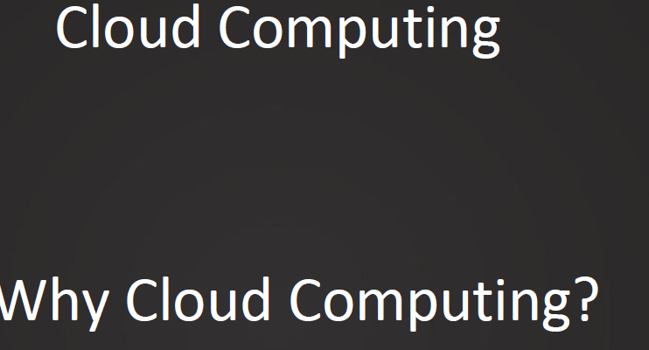

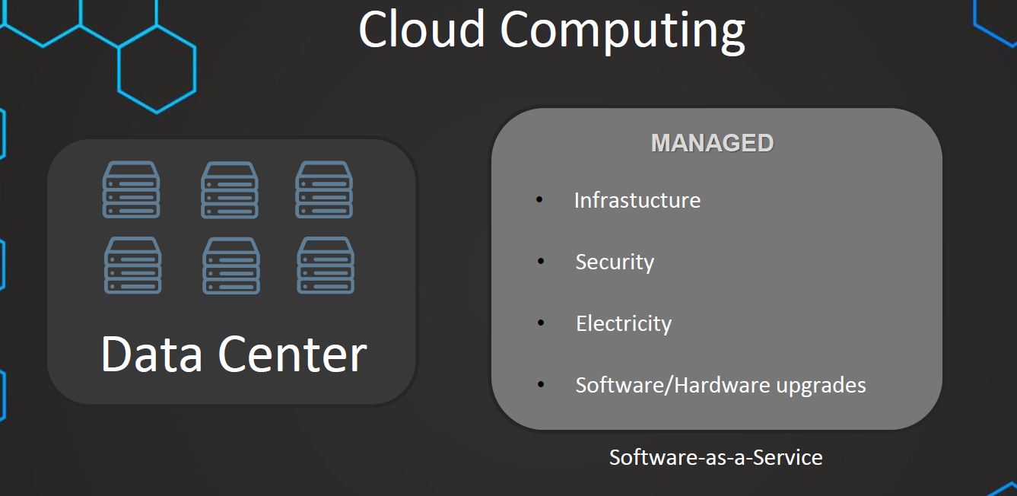

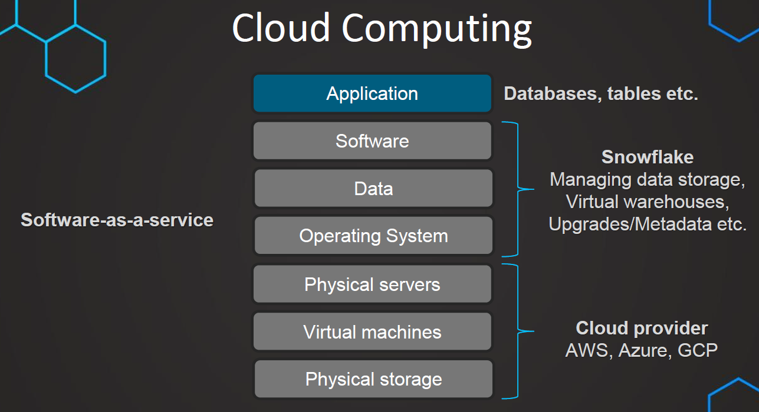

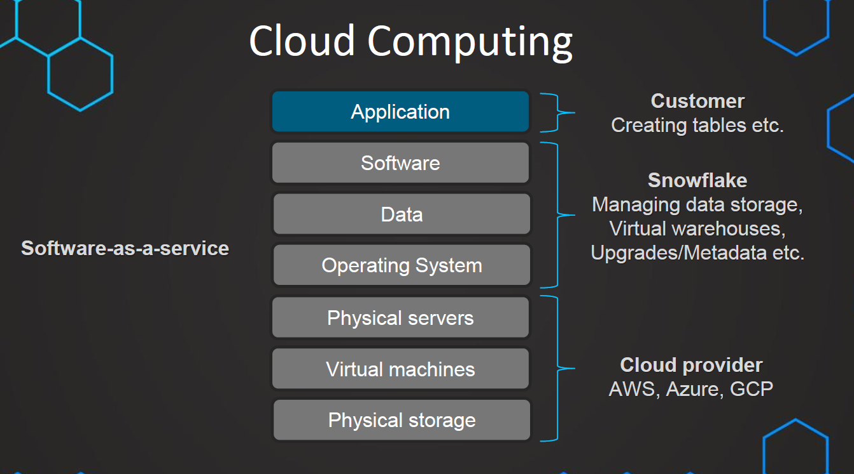



**Note: Snowflake is Software As a Service (SAS)**

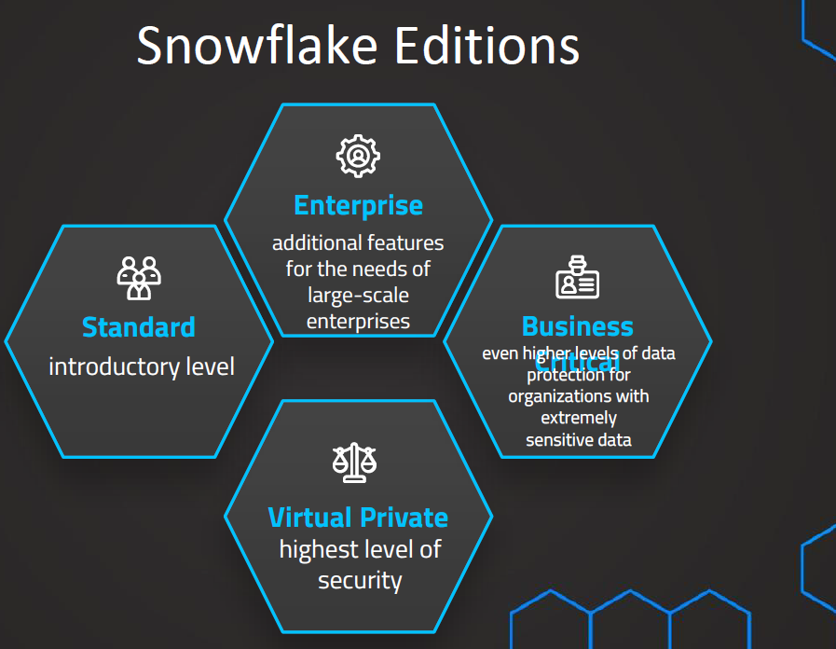

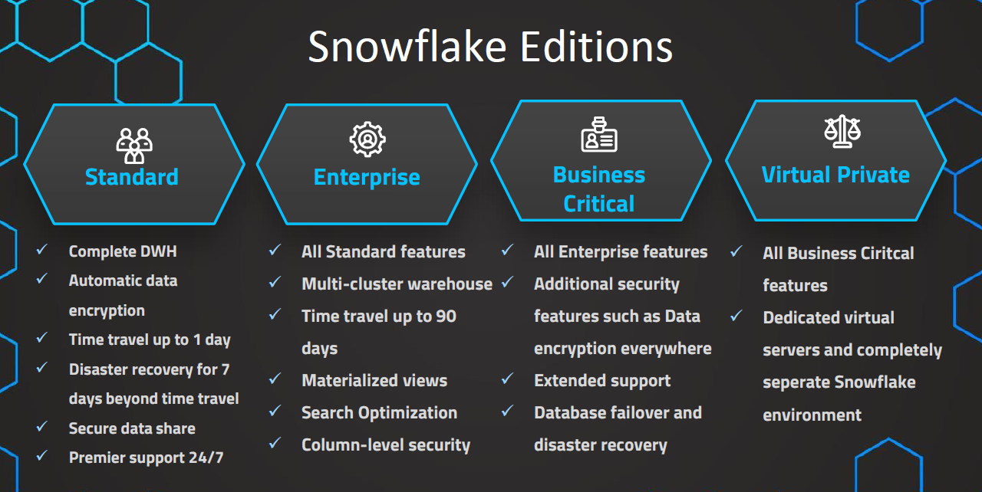

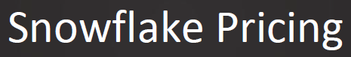

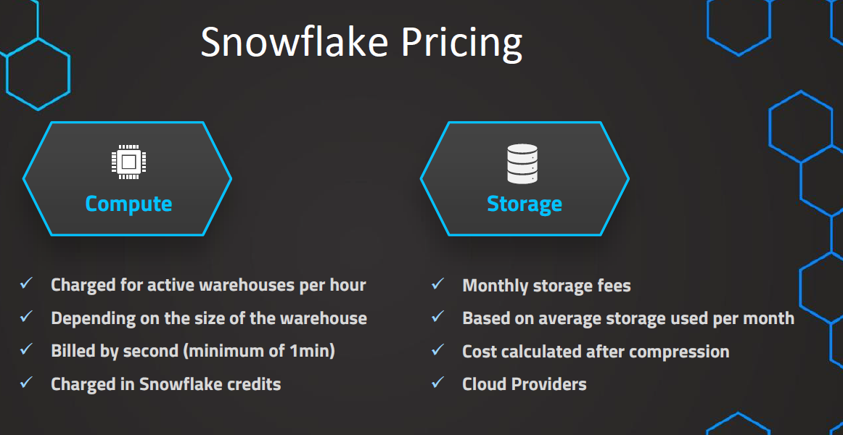

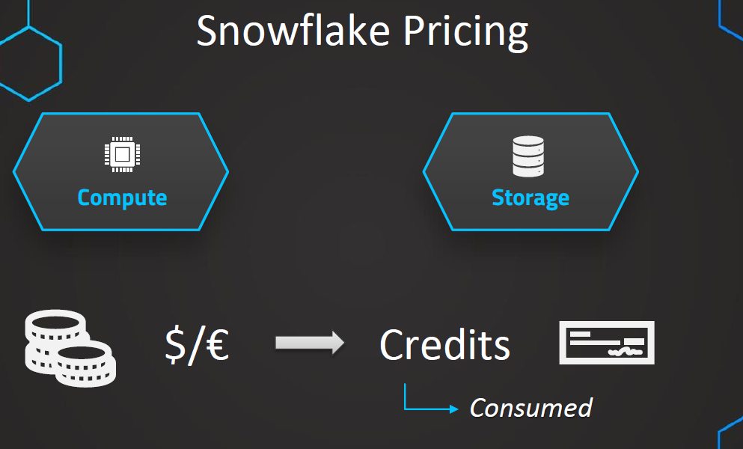

**Compute Is divided into 3 separate parts**

**1.(Active) warehouses Standard - (Used for executing Query Processing)**

**2. Cloud Services (only charged if exceeds 10% of warehouse consumption)**

**3.Serverless (search Optimization ,snowpipe ,automatically resized)**

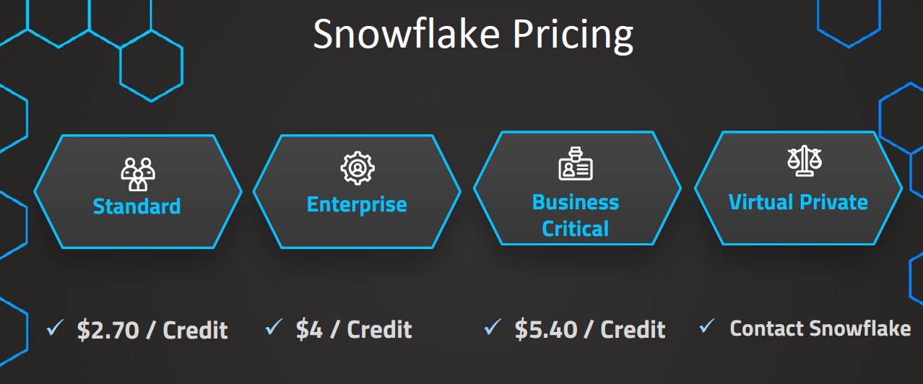

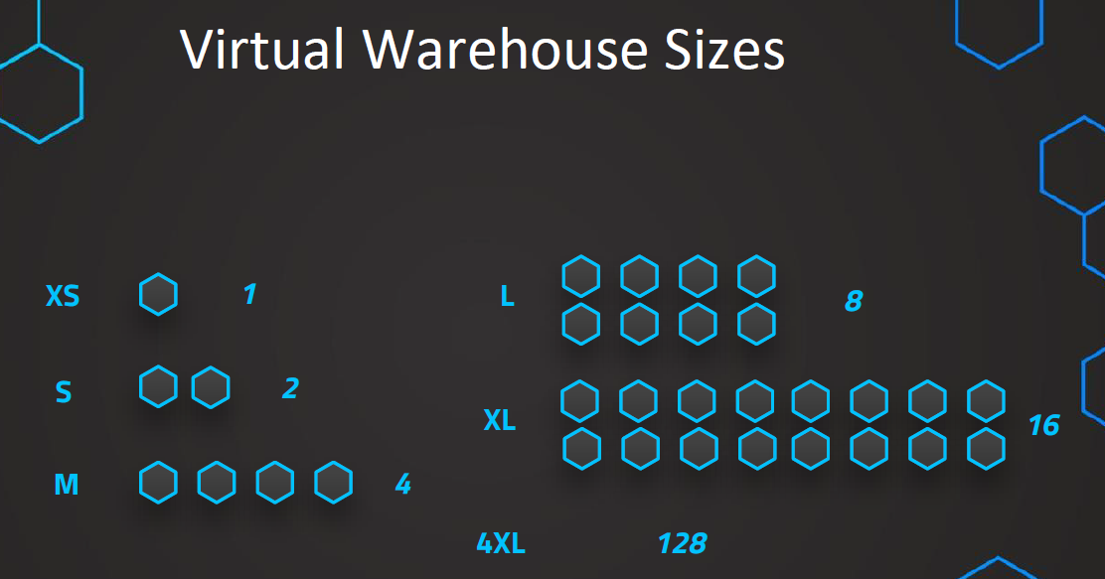

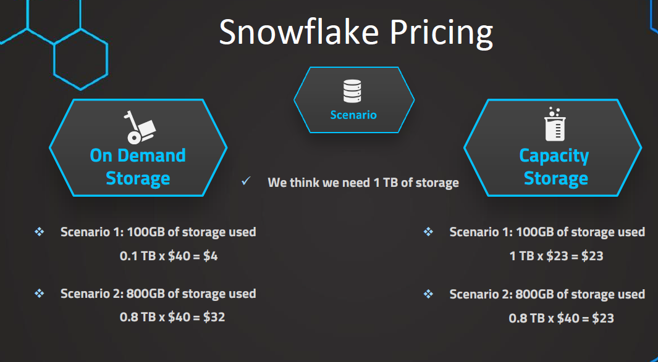

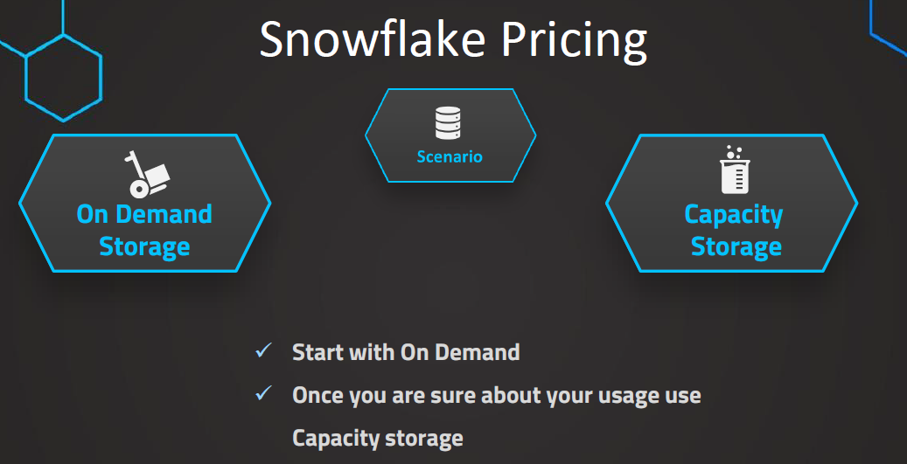

**Storage Pricing**

**There Is monthly fee for storing.**

**Based on Average storage used for month**

**This depends on Cloud provider (AWS ,GCP ,Azure ) and Region**



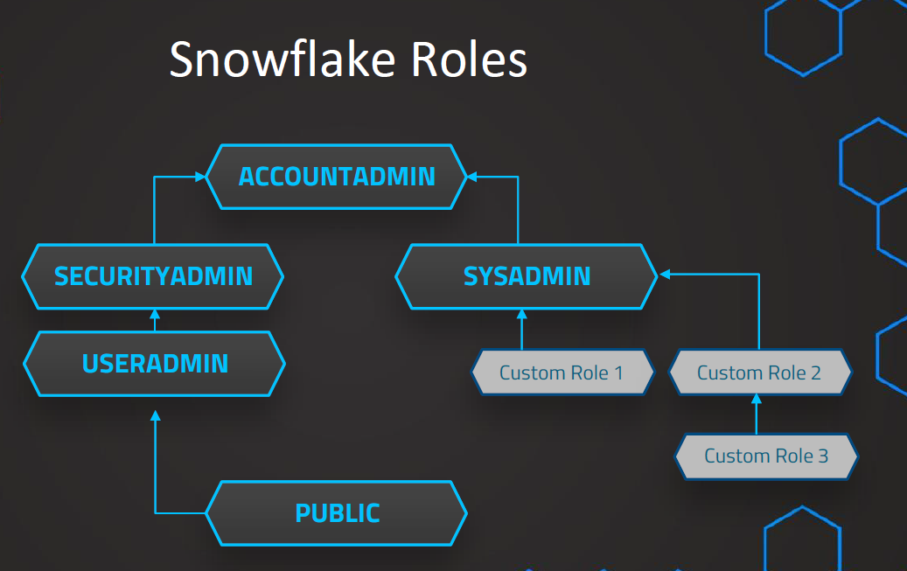

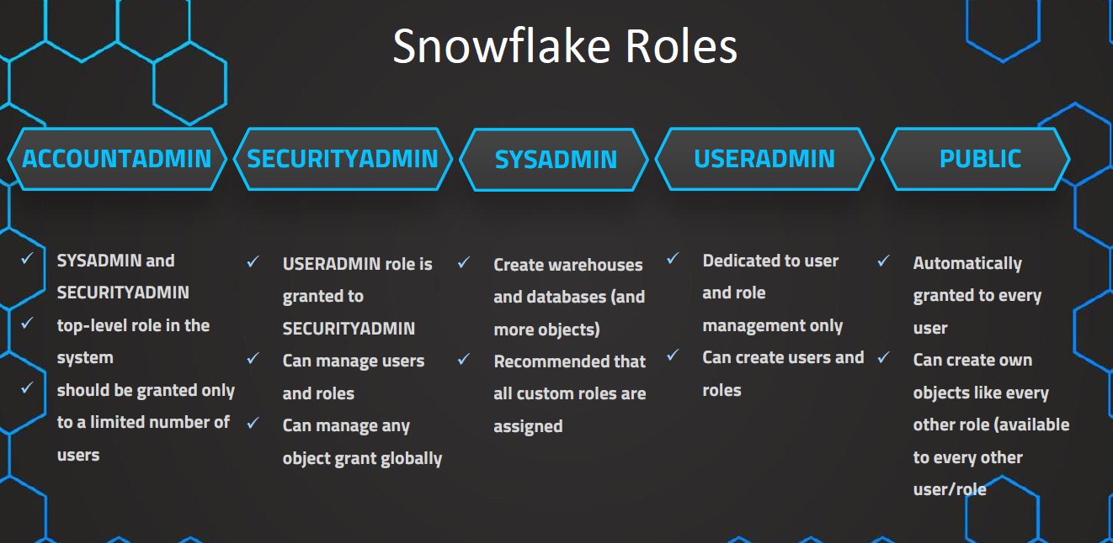

**Data Ingress (Getting data into Snowflake is free).**

**Data egress (get the data out of snowflake) CHARGED.**

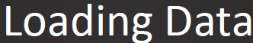

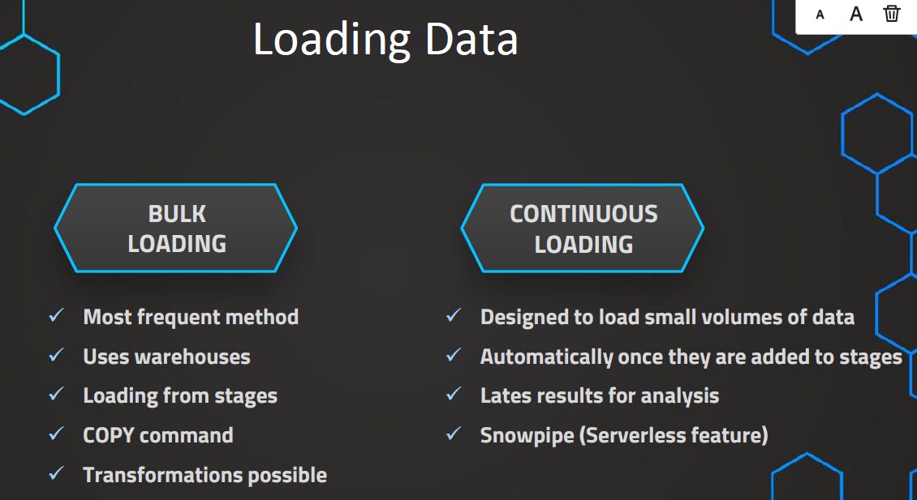

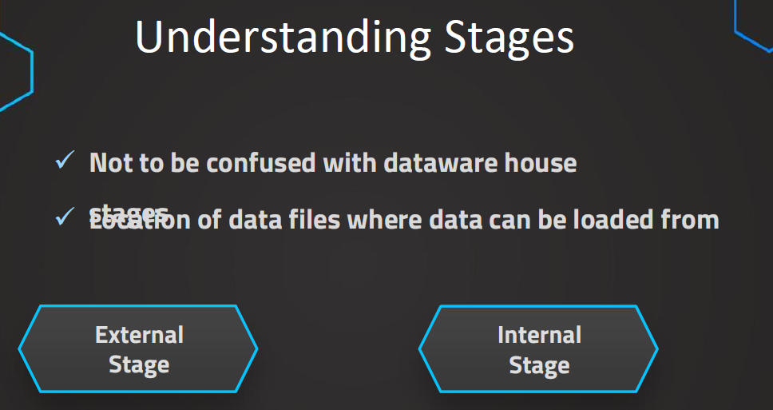

**Stage is Object in Snowflake. This is something that we create, basically location of the data files where the data can be loaded from.**

**Basically, Stage is database object with different properties basically used to load the data.**

**There are 2 types of Stages.**

**1.External Stage**

**2.Internal Stage**

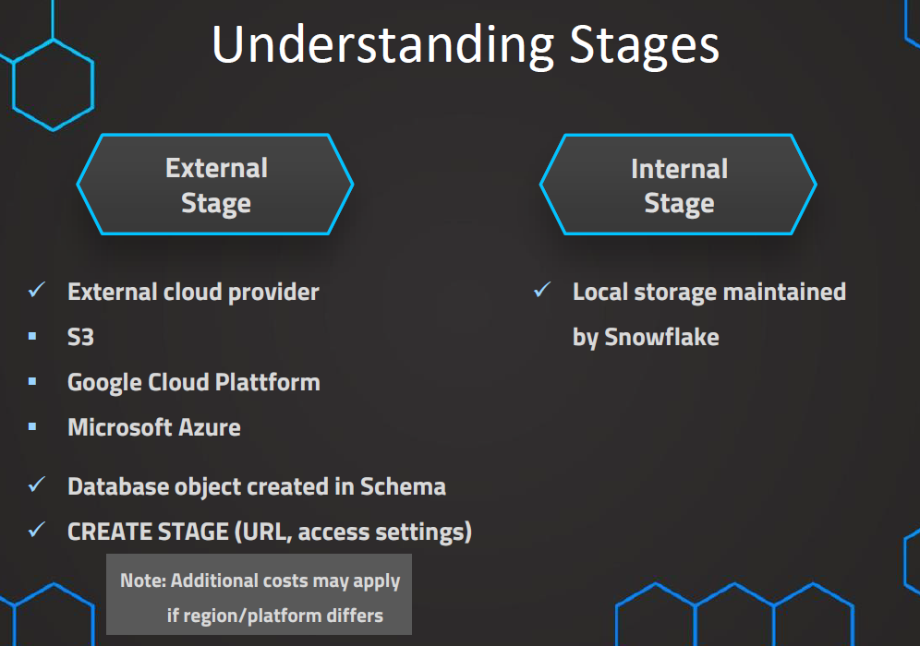

**Create Stage (Home --🡪 Projects --🡪 worksheet)**

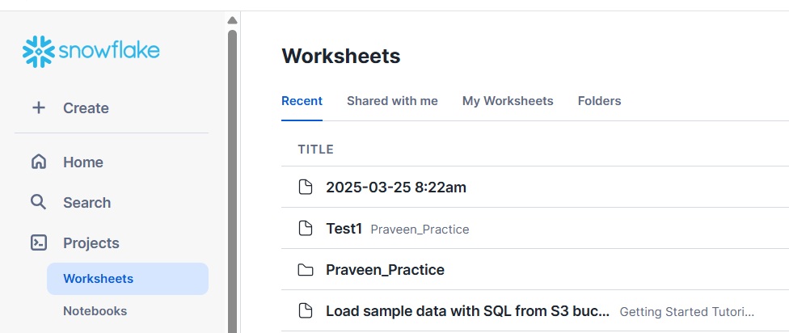

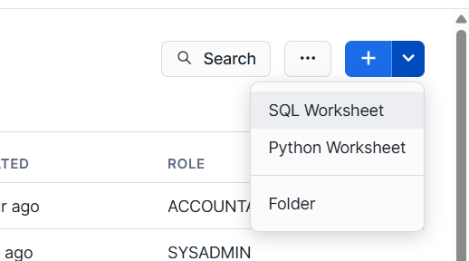

**// Database to manage stage objects, fileformats etc.**

**CREATE OR REPLACE DATABASE MANAGE_DB;**

**CREATE OR REPLACE SCHEMA external_stages;**

**// Creating external stage**

**CREATE OR REPLACE STAGE MANAGE_DB.external_stages.aws_stage**

**url='s3://bucketsnowflakes3'**

**credentials=(aws_key_id='ABCD_DUMMY_ID' aws_secret_key='1234abcd_key');**

**// Description of external stage**

**DESC STAGE MANAGE_DB.external_stages.aws_stage;**

**// Alter external stage**

**ALTER STAGE aws_stage**

**SET credentials=(aws_key_id='XYZ_DUMMY_ID' aws_secret_key='987xyz');**

**// Publicly accessible staging area**

**CREATE OR REPLACE STAGE MANAGE_DB.external_stages.aws_stage**

**url='s3://bucketsnowflakes3';**

**// List files in stage**

**LIST @aws_stage;**

**//Load data using copy command**

**COPY INTO OUR_FIRST_DB.PUBLIC.ORDERS**

**FROM @aws_stage**

**file_format= (type = csv field_delimiter=',' skip_header=1)**

**pattern='.*Order.*';**

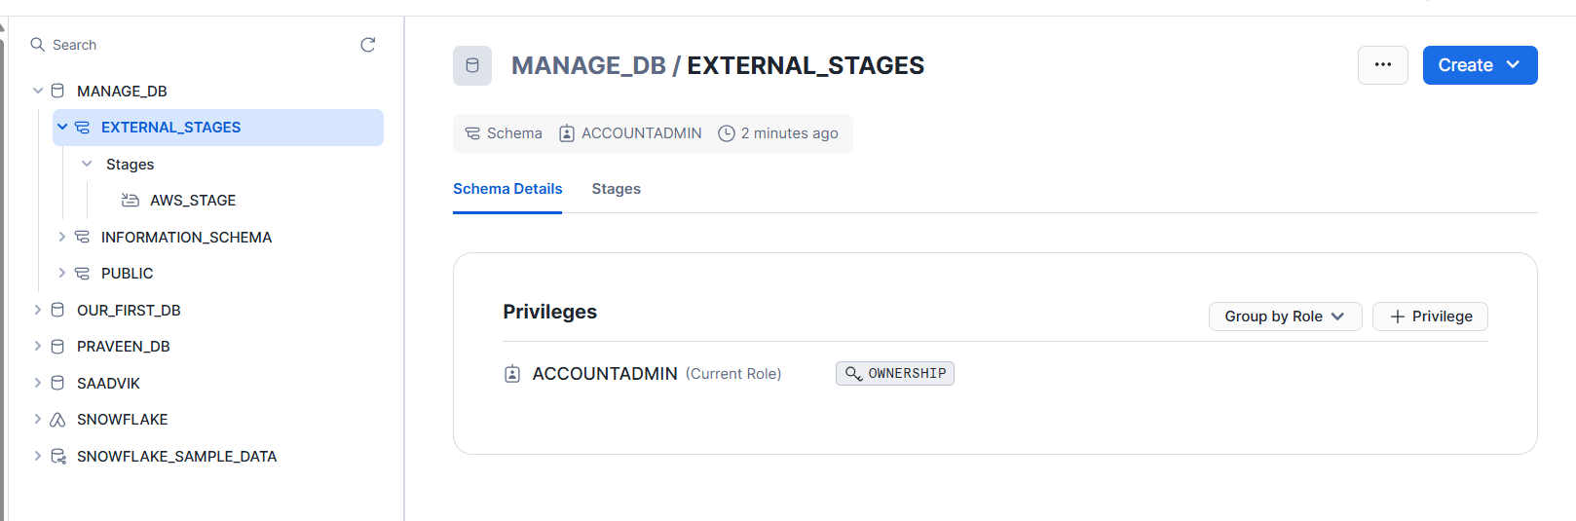

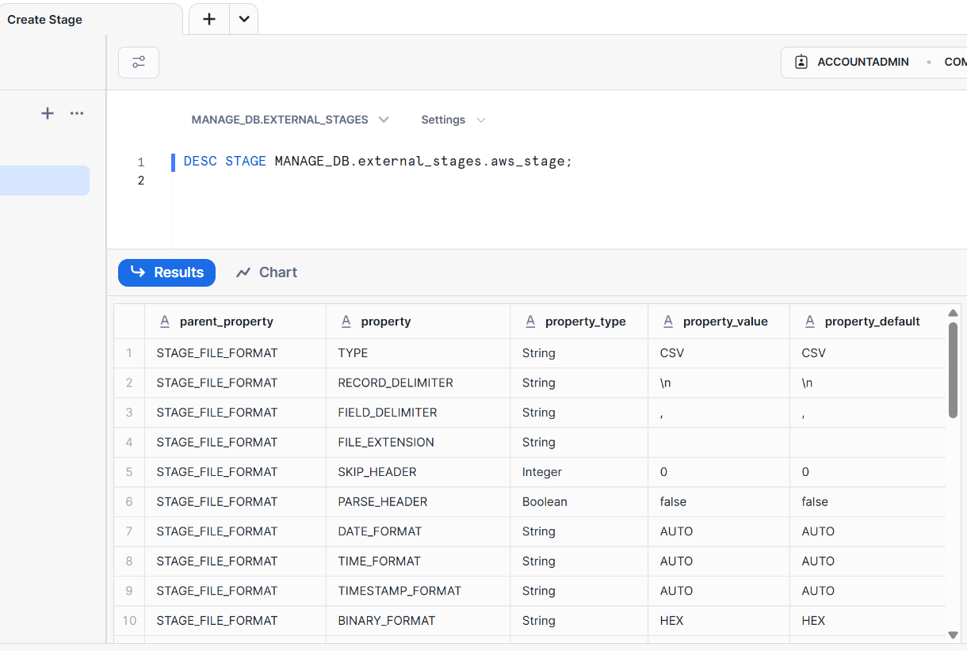

**COPY COMMAND**

**External Stages always refer as “@”**

**// Creating ORDERS table**

**CREATE OR REPLACE TABLE OUR_FIRST_DB.PUBLIC.ORDERS (**

**ORDER_ID VARCHAR(30),**

**AMOUNT INT,**

**PROFIT INT,**

**QUANTITY INT,**

**CATEGORY VARCHAR(30),**

**SUBCATEGORY VARCHAR(30));**

**SELECT * FROM OUR_FIRST_DB.PUBLIC.ORDERS;**

**// First copy command**

**COPY INTO OUR_FIRST_DB.PUBLIC.ORDERS**

**FROM @aws_stage**

**file_format = (type = csv field_delimiter=',' skip_header=1);**

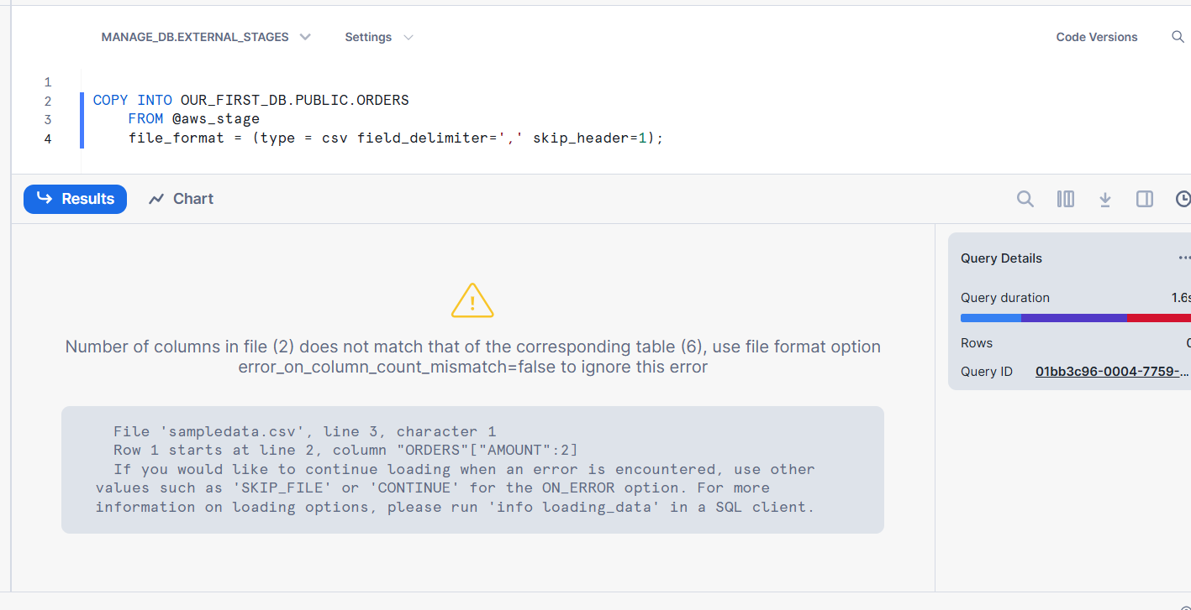

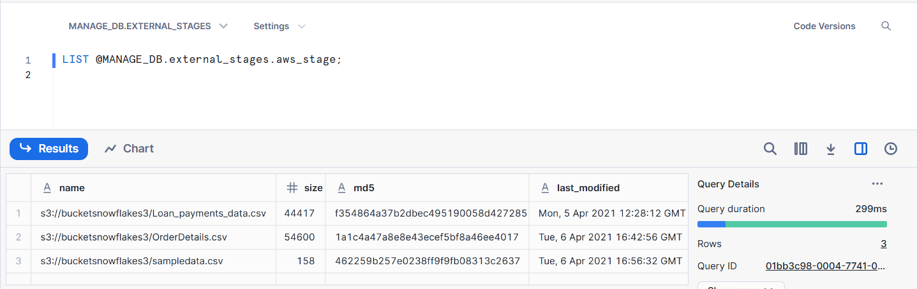

**If we see, we have 3 different files and snowflake is trying to load all of them we didn’t specify the filename.**

**So, we need to specify exact which file we need to load.**

**// Copy command with fully qualified stage object**

**COPY INTO OUR_FIRST_DB.PUBLIC.ORDERS**

**FROM @MANAGE_DB.external_stages.aws_stage**

**file_format= (type = csv field_delimiter=',' skip_header=1);**

**// List files contained in stage**

**LIST @MANAGE_DB.external_stages.aws_stage;**

**// Copy command with specified file(s)**

**COPY INTO OUR_FIRST_DB.PUBLIC.ORDERS**

**FROM @MANAGE_DB.external_stages.aws_stage**

**file_format= (type = csv field_delimiter=',' skip_header=1)**

**files = ('OrderDetails.csv');**

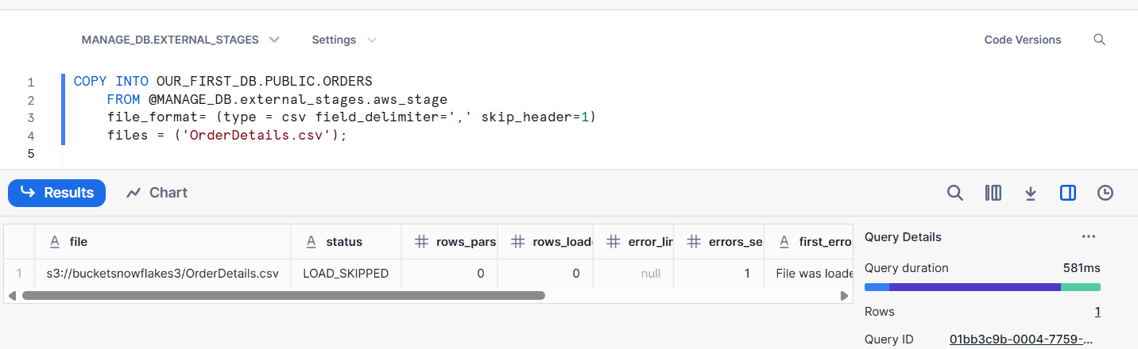

**// Copy command with pattern for file names**

**COPY INTO OUR_FIRST_DB.PUBLIC.ORDERS**

**FROM @MANAGE_DB.external_stages.aws_stage**

**file_format= (type = csv field_delimiter=',' skip_header=1)**

**pattern='.*Order.*';**

